**DSI INCLUSIVE PRACTISES**

Dr Andromachi Nanou & Evaggelia Tsiomi

Include

1. Digital Social innovation in Greece
   1. The action plan: “DIGITAL SKILLS FOR DIGITAL GREECE”

According to the “ Launch of the 2019 Skills Outlook: Thriving in a Digital World” [1] ([OECD Skills Outlook 2019](http://www.oecd.org/skills/oecd-skills-outlook-2019-df80bc12-en.htm)) countries are unequally prepared to seize the benefits of digital transformation*.* A few countries, including Denmark, Finland, the Netherlands and Sweden, are already ahead in this respect. Interventions by policy makers is urgently needed in many other countries that lag behind.

Greece is referred to (along with Chile) as countries where a large percentage of the general population do not have basic digital skills, which means that they need to pursue a broader policy to upgrade their digital skills to their entire population.  
  
In the field of the digital city-rural divide, also, e.g. In terms of broadband internet access, Greece - along with Portugal, Chile and Lithuania - is listed as a country with more than 10% inequality in terms of urban and rural household connectivity. As the report points out, "such digital exclusion is likely to exacerbate other social and economic inequalities"

According to the report, it is not enough for the population to have universal access to the Internet, but the population must also make the most of the opportunities for digitization. "In today's fast-paced digitized world, skills make the difference between leading developments and finding them difficult to follow.[2]"

"If technological change continues to expand the number and complexity of activities that people have to do in their daily lives through the use of digital tools, in some countries people are more likely to lag behind," the OECD warns.

The OECD has been working hard to address many of these challenges and ensure citizens are able to thrive in a digital world. Recent OECD reinforces the key recommendations of the 2019 Skills Outlook.

For this reason in Greece there is an extended effort an action Plan in national level “DIGITAL SKILLS FOR DIGITAL GREECE “for the Promotion of Innovation and Digital Skills The Action Plan was prepared by the Department of Innovation and Best Practices in collaboration with members of the National Alliance[3]

This action plan consists of seventy five (78) actions which were designed and implemented by 19 bodies. The actions implement the goals and priorities that have been set through the analysis that proceeded the first six months of 2018 and which were presented in July 2018 by the Department of Innovation.

Findings and planning Regarding the distribution of the actions of this Action Plan, it is observed that: •The planning of actions by the members of the National Alliance has been oriented to a great extent in strengthening the axis that concerns digital skills of citizens and businesses. These mainly concern the development of basic digital skills. In this way the Action Plan responds to the large deficit highlighted by the latest DESI report of 2018 and concerns the lack of basic digital skills of the population. There is a great orientation of actions in the field of Education which mainly concern teachers' trainings but also the introduction of digital tools in the classrooms in combination with the upgrade of technological infrastructures and laboratories in school units which are planned by the competent Ministry. It is worth noting that the design of the Ministry of Education provides for the adaptation of digital educational tools for children with special educational needs or disabilities, while the state certificate of informatics is also introduced.

1. Digital Social innovation in Inclusive Education in Greece [4]

21st Century School is preparing to include all students and to formulate inclusive educational environments to support their needs. So, inclusion has become the dominant educational approach for children and adolescence with special educational needs (SEN) and disabilities.

Inclusion is a holistic and ongoing process. In this process, aspects of social and cultural environment functions as intermediations and contribute to the maximum extend to child’s and family’s inclusion (Nanou 2017[5], Ballard 2018 [6]). Crucial notions, settings, methods and tools act as Inclusion intermediations that prepare educational environment to accept and welcome the child at risk for exclusion.

One of the basic intermediate notions that affects curriculum development is the Universal Design of Learning, UDL. This notion concerns the way that curriculum concepts, processes or materials designed so as could be accessible to everyone[7] Current work emphasizes that learning occurs in a dynamic interaction between student and learning environment, and that the learning environment is itself complex and dynamic. Engagement with the learning task depends on the provision of a sufficiently flexible curriculum so that each learner can find the right balance of challenge and support. Without support for sustained effort, persistence, and emotion regulation, even students who are momentarily excited about learning can become disengaged, losing out on deep learning. Active engagement with learning is gained through social processes. All students need alternative models of how to achieve a goal, and a sense that the steps to get there are achievable. Engaged students can model these different pathways for one another, but they need UDL to be able to do so.[8]

UDL in inclusive environment becomes more attractive, challenging and accessible for all through ICT. In a relatively short space of time, information and communication technology (ICT) has spread throughout the world as well as within the European Union and digital technologies have led to profound changes across all sectors of society, including education and the school system.[9] Digital technologies can co-create knowledge and solutions for a wide range of social needs (Bria et al., 2015, p. 9). From this point of view while looking for an effective educational and social inclusive model Digital technology is in the front line.

* 1. **DSI practices in education in Greece**

**Eye tracking system or eyegaze**

It is an advanced electronic system that allows the use of the computer through the movement of the individual's eyes. A built-in dedicated camera detects the focus of the eye on special control keys that appear on the screen and are similar to those of the classic keyboard and then through a program this movement is translated as a selection movement in the image that the person is looking at.

Interacting with the gaze or typing with the gaze means producing text using the focus of the gaze. It is mainly needed by people with severe disabilities and may in some cases be the only option for communication. It is a rapidly evolving technology that can now become a standard human-computer interface. Interaction with the eye compared to other interaction devices provides a more indirect way of communicating, thoughts and behaviors. As a natural through choice the look is easy to learn, the interaction with the eyes is not only faster but requires less effort because the user does not engage with the body to select targets.

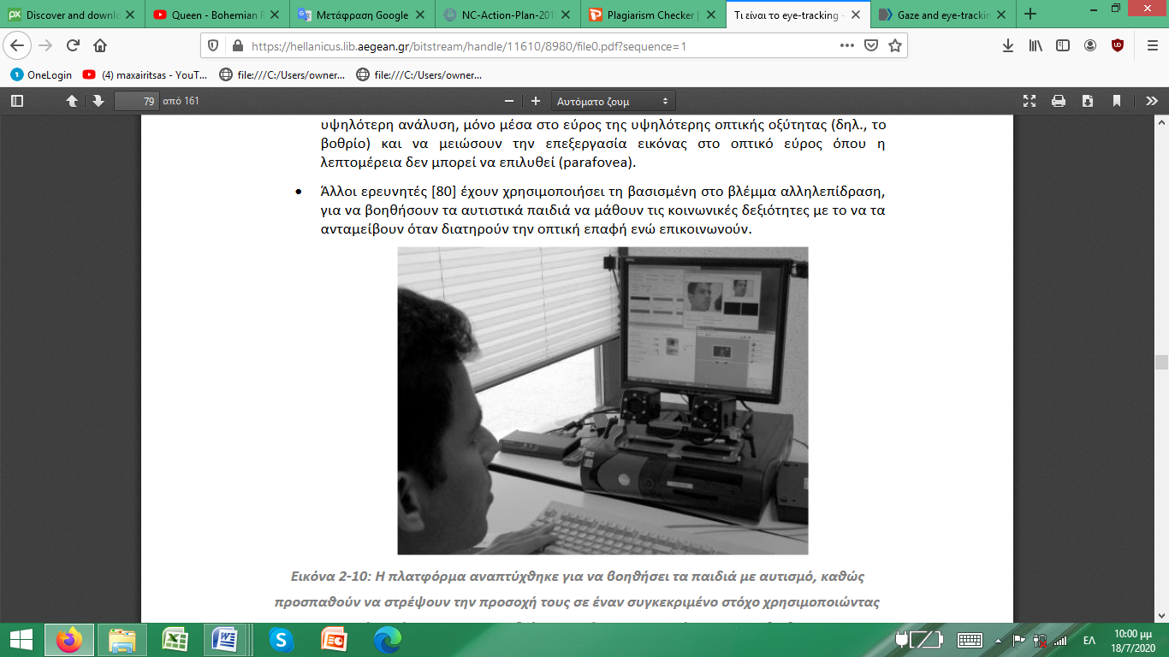The platform was developed to immerse children with autism, as well as to focus their attention on a specific goal using a system that traps their eyes and face.

**ZAC program**

It is the first browser designed for children with ASD. This program allows the child to interact directly with activities that focus on problems of sociability, communication, limited interests and repetitive behavior. It is available in versions for windows, mac and iOs. Also available in English, French and Spanish.

**E-portfolio**

It is the digital version of the traditional student portfolio used by many teachers for decades. The student's electronic portfolio is a technological innovation introduced in the school community, because it can transform and adapt educational goals to the capabilities of each student (Rhodes, 2011 as reported in Yastibas & Yastibas, 2014).

The concept of "individual file" is inextricably linked to the effort to upgrade the role of the student in building knowledge and promoting a self-directed, self-regulating and reflective learning (Tzimogiannis, 2017). The online folder consists of a digitized collection of files, which interacts closely with websites, videos, online encyclopedias, social blogs or even other electronic folders.

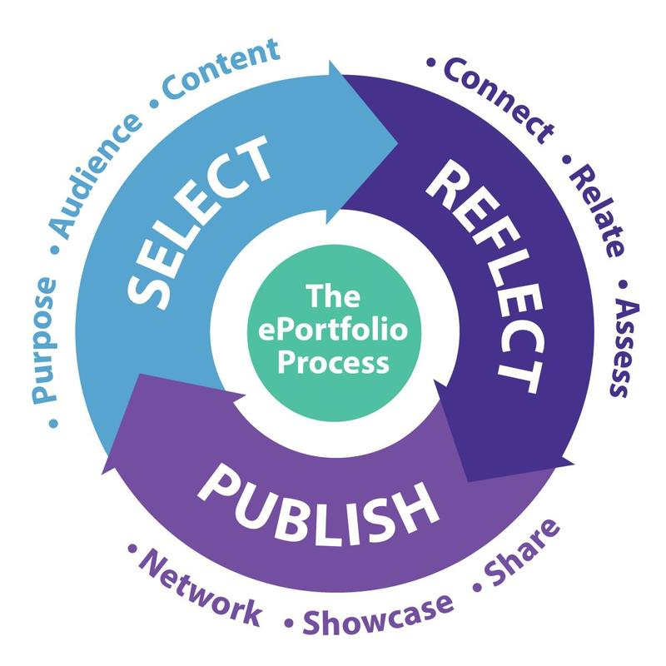

**Daisy**

Made by ROBOTIX and consists of a plush daisy (flower) in which a tablet has taken the place of the face where two oversized blue eyes are projected, in cartoon style, which can look right, left and center. The robot is telecommunicated with another tablet, which is handled by the researcher and directs the game by selecting the phrases recited by the robot. In addition, the robot connects to a speaker to amplify the sound of the tablet.

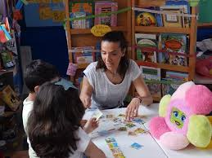

Electronic Pointing Devices are an easy-to-use and highly useful tool for people with multiple disabilities, especially mobility, that allows you to control the screen without the use of hands or other body parts, but relies on ultrasound or infrared technologies and recognizes movement eye or brain waves. There is also a case of a pointing device being activated by the user inhaling and exhaling through lip pressure (http://www.e-yliko.gr/htmls/amea/amea_tools_.aspx). So people with disabilities can express their needs, feelings and emotions, ask questions of others, participate in school activities, play, work, take part in decisions about their future, improve their relationships with their family and friends ”(Tailachidis, 2013: 235-236).

**Thinglink**

The thinglink is a very useful and easy tool, with which we can create interactive images, in which we can insert images and links from the Internet. We can share them through social networks, or embed them in our blog. It also allows us to use it on all devices, as it is also available for mobile phones and tablets.

* 1. **Social Innovation. The case of include**

"Social innovation can be deemed to be the production of new solutions to social problems in a more effective, efficient, and sustainable way" (Marzano)[10]. Interdisciplinary Νetwork for Special and Intercultural education, include, investigates and suggests effective inclusive solutions for formal and non formal educational environments where children with disabilities or different cultural back ground and their families are being included. In this sense include suggests best Inclusive practices and solutions. In a sense, it is a social Innovation.

include develops action – research to investigate how digital kind of play or digital tools affects the participation of both typical and non typical children and their interactions. Digital technology acts as a magnet bringing together typical and non - typical children, improving their interactions (Nanou & Patsidou 2017). Action-Research has been developed through stages so that the results of every stage to be used as the base of the next. A lot of effective Digital inclusive practices for all are evidence-based.[11] All these practices have been applied in “School for all “the place where action research of include take place. DSI Inclusive practices have been developed for all children with Special educational need or disabilities and are presented below:

**Bee bot play for improving creating writing interactions of children with developmental language disorders in inclusive environment.[12]**

Children with developmental language disorders can, with appropriate intervention, improve their communication skills. Such interference strengthens their interaction through an inclusive creative writing program with educational robotics activities. Children construct mechanical structures (building blocks) while solving real problems from the natural world that surrounds them. That makes a parallel learning environment and a play-back environment, safe for testing and searching, suitable for the development of complex cognitive objects is created, where collaborative learning exploits children's interest in new technologies and in particular computers. With these characteristics educational robotics is an example of modern technology. It exudes children with computers, but removing them from the narrow limits of the screen in the tangible, real world. Each training package contains a processor (mind), sensors (sensors), motors and building blocks for construction and creation. "Building Creation" is programmed in a simple programming language - designed for students of different ages and abilities - to make a living action desirable.

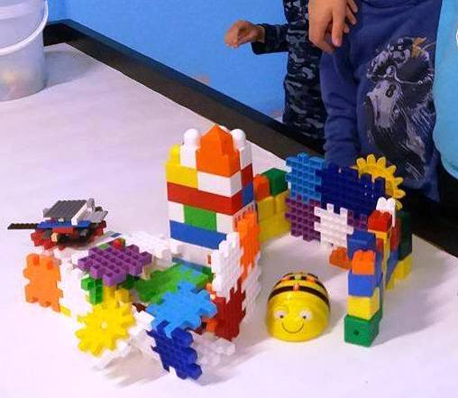

Fig. 3 The aim is not to learn technology, but with the help of technology knowledge and digital power to change attitudes and perceptions of knowledge and learning. In other words, it provides the possibility of achieving discrete goals and positive impacts, such as improving analytical and synthetic thinking, creativity and innovation, critical thinking, problem solving, teamwork, developing communication skills and project management skills .

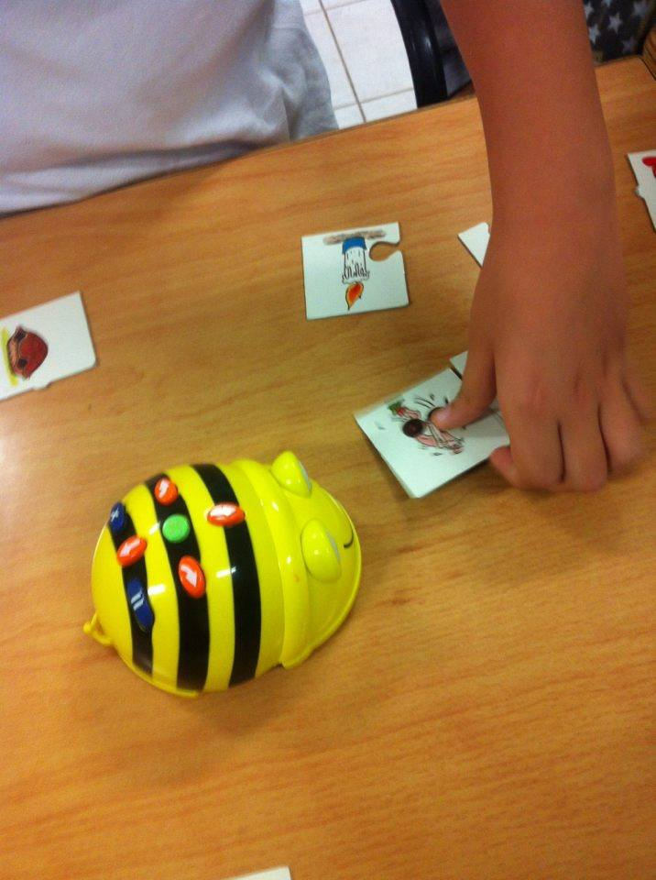

With the help of the technological tools, especially with the beebot (suitable for programming at younger ages), it was attempted to investigate the results of the intervention through an organized case study of a child with speech problems. A structured program of activities was carried out within a group, and the methods of systematic and participatory observation were used. The results of the child's expressive ability, obtained by collecting data from the observation protocols and comparing the evaluations (initial and final), can be described as encouraging.

They are directly linked to the association of two seemingly incompatible scientific fields, but they are subject to a relevant system of operating rules and are one passage towards each other, especially when they concern small age groups or children with cognitive or social-emotional problems. Robotics is a modern way of educational approach and creative writing an ambitious and auspicious system of integrated expression and study of language at all ages. The cooperation of the two can be an educational proposal for teaching, but also for intervention in children who need special educational counseling in the fields of language and communication (Panagiotou, 2018).

**Video modeling. Why do children with Autism Spectrum Disorders need to be engaged in a learning activity? [13]**

Children engaged in an activity will learn much faster. Video modeling is a tool used to stimulate the visual senses. Children with ASD are visual learners and learn from visual teaching.

“To learn, you need to be paying attention. Anything that detracts your attention is going to have a negative effect on observational learning. If the model is interesting or there is a novel aspect to the situation, you are far more likely to dedicate your full attention to learning.”Bandura, A. (1977). Social Learning Theory. Englewood

Cliffs, NJ: Prentice Hall.

The educational reformer, philosopher and psychologist John Dewey believed that education should be child-centered, active and interactive, and that education must involve the child’s social world and community. (Dewey, J. The child and the curriculum. University of Chicago Press, 1902.)

Where can Video Modeling be used?

VM can be used in therapy, school, home or anywhere there is access to video equipment. Since repetition is vital, using VM in multiple places is a great benefit of using VM in practice as it can be used almost anywhere.

What can Video Modeling teach?

Evidence-based studies have shown that VM can teach communication, academic, play, functional, life and social skills. In addition, VM can work to reverse bad behavior and replace with proper behavior. Watch Me Learn videos based on real life scenarios capitalize on this by teaching multiple skills within one scenario. As in real life, utilizing skills does not happen in isolation.

How to use Video Modeling in practice

Using Video Modeling is simple. Video Modeling simply needs to be watched to be effective. In practice, Video Modeling can and should be used in a more complex way. To maximize learning, Video Modeling is used to teach skills through modeling. Practicing the skill is essential for generalization. This practice should start within a context similar to that of the video. Once this is successful, the natural progression is to practice the skill in different real-world environments, to master generalization.

“The more one has practice, the more likely one is to generalize what one has learned into a style of problem solving or inquiry that serves for any kind of task…or almost any kind of task”

J.S. Bruner 1961

“Ideally”, Jerome Bruner writes, interest in the material to be learned is the best stimulus to learning” (Smith, M.K., ‘Jerome S. Bruner and the process of education’, The encyclopedia of Informal Education, 2002.)

When Can Video Modeling Be Used?

Video Modeling (VM) can be used at almost anytime. Utilizing VM in practice depends on the children or child. Because children love to watch, some teachers and parents use VM as a reward. VM can be used during teaching periods in school. VM can be used as “homework” at home at a convenient time. Children usually write their homework. VM allows them to watch their homework.

**Improving social interactions of young children with autism in inclusive settings through Bee bot play**

Children with autism face many difficulties when it comes to communicating and having social skills. Properly designed educational methods give those kids the opportunity to develop their social skills and interact with others. Educational robotics is a very attractive way of use the IT in educational programs designed for special kids because they appeal to every child all over the world. The aim of this study is to design and use an interventional program for autistic children, trying to help them evolve their social and communicational skills. After mentioning the main theories connected to autism, a quality research was conducted with a case study of an autistic child. Throughout the research innovative teaching methods were used and new educational tools were developed.



Εικόνα 4 Bee bot supports communication skills of children with autism

The results were very satisfying and the kid participating in the study succeeded in developing her social and communicational skills. A further study on the phenomenon is also suggested as educational robotics can become the key tool in helping children with autism interact with their social surrounding (Kotou,2018)

**Self awareness in digital environment**

Yoga is a physical and mental practice that has a meditative core. The goal is, through a stable and comfortable body , to finally immobilize the restless mind.(The Yoga Sutras of Patanjali)

1)Goals

The aim of the research is sensory synchronization, the improvement of social relations as well as the proper management and balancing of the fluctuations of the mind ,through yoga sessions . The aforementioned has been proven to be achievable by using digital media that helped the techniques used in sessions.

2)Methodology

In this research, participates Hara, an 11-year-old girl with autism and takes place in a specially designed area, where controlled sensory stimuli are transmitted. Through a sequence of courses, we have thoroughly researched and ending up with specific techniques that have proven to have an effect on the management of sensory fluctuations ,on the improvement of body perception (Journal of Ayurveda and integrative medicine 1 ,2010)as well as on improving the emotional and social ability of the individual. An extremely effective technique is the breathing process (Nadis Sodhana ) as well as the reproduction of sounds at the frequency and intensity required by the child’s condition.

The first and most important condition is the type of lightning, and then the use of frequencies that function as a safety status or reassignment for the child with autism. we have created a fertile ground for the practice, the practitioner follows a sequence of exercises by copying the teacher or by copying projecting images, with great success. The session is completed with deep relaxation, the duration of which, increases impressively overtime.

3) Results

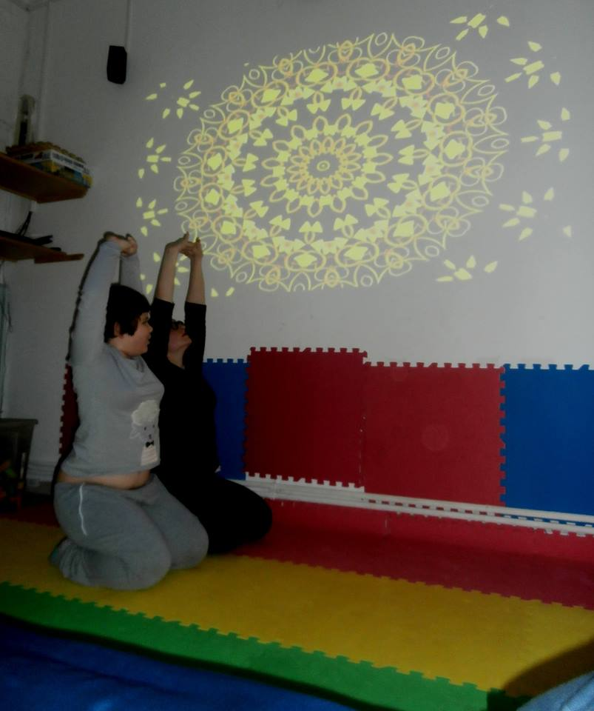The result is to have a child with autism who seeks the systematic practice , because she feels the benefits and facilitations that yoga provides in her everyday life. Hara has improved her mimetic skills, her sensory distinction and her emotional management by remaining calm for a long period. She has also improved her social skills, resulting her participation in activity groups composed by typical-development children. The digital media we use systematically ,is a mandala wall projector, specially adjustable lightning, and, of course ,an adjustable audio player. So, Yoga, under digital conditions, can empower and contribute to the process of improving interactions of people in autistic spectrum disorders (Kontogianni & Nanou 2020).

Fig. 5 DSI yoga practices mandala wall projector, specially adjustable lightning

BIBLIOGRAPHY

1. Nanou A, Patsidou M. (2017). Exploring the characteristics of an effective educational model in a school for all. Issues in Special Education, Vol .77. –May July, 58-77 (Αναζητώντας τα χαρακτηριστικά ενός αποτελεσματικού μοντέλου εκπαίδευσης σε «ένα σχολείο για όλους». Θέματα Ειδικής Αγωγής Τριμηνιαία περιοδική έκδοση για την εκπαίδευση Τεύχος 76 , Αύγουστος – Σεπτέμβριος.)

## Kontogianni , M, Nanou, A. 2020 . Teaching self-awareness and self-regulation techniques to a child with Autism Spectrum Disorder''SOCIETY. INTEGRATION. EDUCATION'' Conference Proceedings 22.05.2020. RTA Rezekne LATVIA <http://journals.rta.lv/index.php/SIE/article/view/5148>

Kotou Despoina 2017. Design and implementation of a innovative educational program through structural approach with the objective of the development of social and communication skills of children in the autistic spectrum. MA Dissertation EUC.

Panagiotou G. 2018, improving creating writing interactions of children with developmental language disorders in inclusive environment MA dissertation University of west Macedonia

1. Sofos, Costas, Paraschou: Online Distance Education (2015)  
   Taylachidis, S. (2013). Applications of ICT in special education. THE EDUCATIONAL: issue 109-110, pp.227-240.
2. Taylachidis, S. (2013). Applications of ICT in special education. THE EDUCATIONAL: issue 109-110, pp.227-240.
3. Tsiomi , E, Nanou, A. 2020. Cooperative strategies for children with Autism Spectrum Disorders in inclusive robotic activities ''SOCIETY. INTEGRATION. EDUCATION’’ Conference Proceedings 22.05.2020. RTA Rezekne LATVIA <http://journals.rta.lv/index.php/SIE/article/view/5147>

# Tsiopela, D., & Tzimogiannis, A. (2017). ICT in the education of people with Autism Spectrum Disorders: A literature review. Science and Technology in Education, 10 (1), 19-35.

Useful link

[ThinkLink: δημιουργήστε εύκολα και γρήγορα διαδραστικές εικόνες! – EdTech.gr](https://edtech.gr/thinklink/)

[Αρχική - e-Portfolios](http://e-portfolio.sch.gr/)

[Zac Browser Gold: Περιηγητής για παιδιά με αυτισμό](https://www.specialeducation.gr/frontend/article.php?aid=723&cid=145)

[ThinkLink: δημιουργήστε εύκολα και γρήγορα διαδραστικές εικόνες! – EdTech.gr](https://edtech.gr/thinklink/)

[www.anastasis.it](http://www.anastasis.it)

[www.minedu.gov.gr/neo-sxoleio-main.html?showall=&start=1](http://www.minedu.gov.gr/neo-sxoleio-main.html?showall=&start=1)

<http://www.e-yliko.gr/htmls/amea/amea_tools_.aspx>

[www.pi-schools/special_education_new](http://www.pi-schools/special_education_new)

[www.thenumberrace.com](http://www.thenumberrace.com)

[www.dyslexia-goneis.gr/view.asp?ItemID=83&ns=1&mcid=9&cid=23&scid=16&page=4](http://www.dyslexia-goneis.gr/view.asp?ItemID=83&ns=1&mcid=9&cid=23&scid=16&page=4)

1. by Angel Gurría OECD at 9 of May 2019 in Paris, France
2. <http://www.oecd.org/skills/launch-of-2019-skills-outlook-thriving-in-a-digital-world-paris-may-2019.htm>

   OECD Secretary-General Γngel Gouria, who presented the report in Paris,
3. https://www.nationalcoalition.gov.gr/wp-content/uploads/2019/06/NC-Action-Plan-2019-FINAL.pdf
4. <http://ereader.ekt.gr/books/ftyg/#p=1> INNOVATION
5. Nanou A., Patsidou M. (2017) Issues on Special Education . Quarterly magazine for education Issue 76, August - September
6. Ballard 2018 [Inclusion, Paradigms, Power and Participation](https://www.taylorfrancis.com/books/9780429469084/chapters/10.4324/9780429469084-1) in (Catherine Clark, Alan Dyson, Alan Millward eds) Towards Inclusive Schools?
7. <http://udltheorypractice.cast.org/login>
8. http://udltheorypractice.cast.org/reading?6&loc=intro.xml_l1069
9. DIGITAL SOCIAL INNOVATION: A PRELIMINARY PORTFOLIO OF COMPETENCIES FOR SCHOOL SOCIAL WORKERS

   Gilberto Marzano,1,2 Joanna Lizut,2 Luis Ochoa3
10. Gilberto Martzno SOCIAL INNOVATION
11. (Sakalidou, Stathopoulou, Gavriilidou, Nanou 2015, Patsidou, Nanou, Rapatopoulou, 2015 Raptopoulou, Tsiomi, Nerantzis, Nanou, 2017 Tzaferis, Tsiomi, Vassiliou, Nanos 2015, Panagiotou 2018, Kotou, 2017, Nanou& Patsidou 2017).
12.
13. Sakalidou Eriffily (in progress)