



**Digital Social Innovation**

**Erasmus + K2 Strategic Partnerships - 2018-1-IT02-KA204-048479**

**Partners experiences and contributions**

**DSI skills and competencies through lifelong learning**

**Ecoistituto del Friuli Venezia Giulia**

**Introduction**

The advent of the fourth industrial revolution is ultimately transforming society and as well as the labor market. The disruptions are unsettling. For instance, according to McGrath (2018), autonomous vehicles will cause massive transformations in the transportation industries and related sectors with significant loss of jobs.

Overall, digital technologies are bringing about vastly changes and will increasingly condition participation in society.

The report by Deloitte Global and GBC-Education, *Preparing tomorrow’s workforce for the Fourth Industrial Revolution, For businesses: A framework for action*, claims that two-thirds of today’s five-year-olds will, in about 15 years, find themselves in jobs that don’t exist today while the jobs that doexist won’t necessarily be located where the job seekers live.

Nowadays, skills such as flexibility and creativity are becoming relevant and are deemed to be considerably more important tomorrow. Recently, it has been observed that:

As it currently stands, 25 percent of today’s workforce will either need to find new professional activities by 2020 or significantly broaden their technological skills as well as their digital citizenship and classic skills—i.e., their cross-disciplinary skills. These skills include programming, agile working, and adaptability. Even elementary school students need to get ready for the change, since by 2030, 85 percent of them will work in professions that do not yet exist. (Enders et al, 2019, 2)

Three key factors have been identified significantly impacting on the acquisition of skills for the future workforce (Enders et al., 2019):

1.    Build transparency in future skills education and further training;

2.    Strengthen the first education system with future skills content;

3.    Expand the future skills further training system (second education system).

Transparency is necessary to create an informed understanding of opportunities and issues in the future labor market.

Interactive online platforms should be developed to establish transparency over the skills profiles of students and graduates. These platforms should support users not only in measuring their future skills, but also should give information on the range of future skills which are particularly in demand, and find tailored training offerings.

Furthermore, students should be provided with teaching focusing on cross-disciplinary skills rather than subject-specific skills.

A few years ago, the University of Phoenix and U.S. Chamber of Commerce explored, independently, the skills employees need to succeed in the workplace. This study identified five soft skills that workers say are most important when it comes to getting hired and being successful in the workplace (University of Phoenix, 2011):

* Ability and willingness to learn new skills (84%);
* Critical thinking and problem solving (82%);
* Collaboration and teamwork (74%).

Figure 1 shows the complete list of skills.

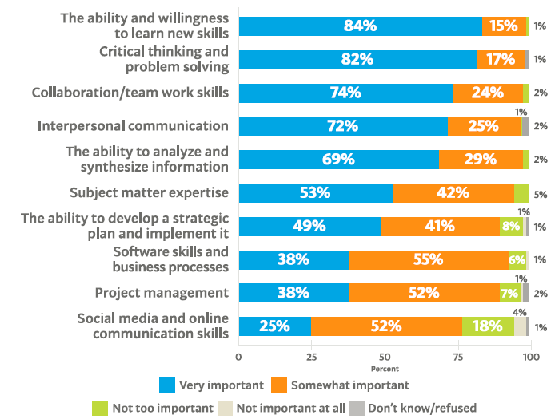

Figure 1. Importance of skills when hiring (source: University of Phoenix, 2011, 4)

Many of the above soft skills have been indicated being essential for the future workforce.

A mix of new forms of postsecondary education and “learning by doing” in the workplace has been suggested to facilitate the acquisition of the new skills and shape education and training to the needs of the ongoing societal changes.

This chapter focuses on the professional development to support personal growth and career opportunities in the future labor market.

**Critical thinking, problem solving, and creativity**

Critical thinking, problem solving, and creativity can be viewed as components of innovation processes.

It has been observed that a creative process can be intentional or accidental (Runco & Pritzker, 1999) and closely tied to innovation (Van Holm, 2015). Accidental creativity and accidental innovation take place when a fortunate discovery occurs by accident, e.g., when one is not looking for it (Beale, 2007). Accidental creativity is addressed as *serendipity,* namely *blind creativity,* and plays a part in animals and machine creativity.

Any intentional or accidental creative process also implies an evaluation of the process results. Evaluation requires self-criticism and reflection. It is important for establishing if an idea is a new one or it is just the re-adjustment of something done before.

In defining the *simplex creative problem-solving* process, Basadur (1997) used interchangeably the terms innovative thinking, creative problem solving, change making, creative thinking, creativity, and innovation.

Basadur (1998) defined an eight-steps circular process for problem solving creativity (Figure 2):

1. problem finding (anticipating future problems and seeking current problems);
2. fact finding;
3. problem defining;
4. generating potential solutions,
5. evaluating potential solutions;
6. action planning;
7. gaining acceptance;
8. taking action.

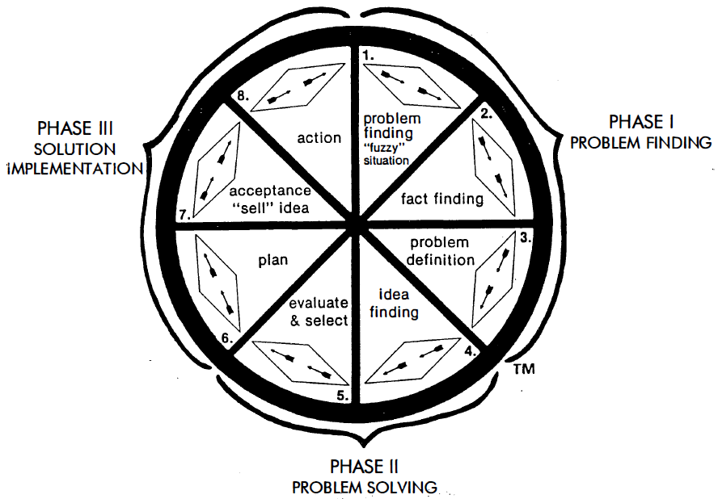

Figure 2. The Basadur’s eight steps creativity process

Basadur argued that, in a dynamic and effective organization, employees should have new thinking skills and reframe their jobs, e.g., becoming creative problem finders and solvers and solution implementers. In this purpose, the organization should provide a framework for directing these creative thinking skills to support its important goals and objectives.

However, two important factors influence problem solving: the nature of the problem (the problem domain) and the kind of knowledge brought to the problem by the solver.

Furthermore, it was observed that creativity seems to be based on unforeseen combination of existing ideas or evidences (Taylor, 1988). This was the famous case of Henry Ford who applied the Roebuck assembly line techniques to the automobile industry or the case of Thomas Edison who developed the electric light bulb combining the property of carbon thread and vacuum.

Researchers in the field of Artificial Intelligence are persuaded that a machine can be programmed in order to simulate the combination of existing pieces of knowledge and expertise to find new solutions to a problem, although they agree that is very hard simulating the richness of human associative memory and representing the problem in computational form. They argue that creativity is not a special “faculty”, nor a psychological property confined to a tiny elite but is grounded in specific cognitive capacities such as the association of ideas, reminding, analogical thinking, and searching a structured problem-space (Boden, 1996, 1998).

**Soft skills importance**

According to the Education Commission (2017), it has been predicted that by 2030, more than half of the nearly 2 billion youth worldwide will not have the skills or qualifications necessary to participate in the emerging global workforce.

In this perspective, it is strategic supporting the acquisition of skills that are important for the future jobs. They should include work readiness skills, soft skills, technical skills, and entrepreneurial skills. To meet the needs of the future labor market learning and training should be interactive, multicultural, engaging, constructive, and practical.

To tackle the challenges of the fourth industrial revolution, technical skills are fundamental. They concern knowledge and capabilities to perform specialized tasks and should include computer programming, coding, project management, financial management, mechanical functions, scientific tasks, technology-based skills, and other job-specific skills.

However, there are other skills, addressed as soft-skills, that play a relevant role. They encompass communication, critical thinking, creative thinking, collaboration, adaptability, initiative, leadership, social emotional learning, teamwork, self-confidence, empathy, growth mindset, cultural awareness. Other qualities that could facilitate employability are innovation, creativity, industriousness, resourcefulness, resilience, curiosity, optimism, risk-taking, courage, and business acumen.

Research confirms the importance of the above qualities and new educational programs should be developed to incorporate social and emotional learning (SEL) and enhance learners intrapersonal, interpersonal, and cognitive competence (Gibert, Tozer, & Westoby, 2017).

**Digital competences and skills**

New skills and competencies related to digital technologies are required to meet the ongoing societal changes.

Digital competence, creativity, entrepreneurship, and learning-to-learn are emerging as key factors for innovation, growth, and participation in society and economy.

Digital Social Innovation (DSI) is a new field that conjugates digital technology and social innovation. It is an evolving and broad field:

A type of social and collaborative innovation in which innovators, users and communities collaborate using digital technologies to co-create knowledge and solutions for a wide range of social needs and at a scale and speed that was unimaginable before the rise of the Internet. (Bria et al., 2015)

In 2018, the European Commission presented a Digital Education Action Plan (COM(2018)22), a proposal for a Council Recommendation on Promoting Common Values, Inclusive Education, and the European Dimension of Teaching (COM(2018)23) and a proposal for a Council Recommendation on Key Competences for Lifelong Learning (COM(2018)24). In addition, in April 2018, the Commission also presented two documents: Communications on Disinformation (COM(2018)236) and Communication on Artificial Intelligence (COM(2018)237).

These documents contain a new set of specific policy initiatives on continuous education and training in order to help people to maintain employability and overcome skills mismatches in a rapidly evolving labor market impacted by globalization and technological changes.

The European Commission Joint Research Centre (JRC) has had a primary role to identify and design the digital skills and competences necessary to face the ongoing societal changes.

JRC is the European Commission's science and knowledge service that develops studies on the labor market implications of the digital transformation.

JRC current research covers the following projects:

* Digital Competence for citizens ([DigComp](https://ec.europa.eu/jrc/en/digcomp));
* Digital Competence for Consumers ([DigCompConsumers](https://ec.europa.eu/jrc/en/digcompconsumers));
* Entrepreneurship Competence ([EntreComp](https://ec.europa.eu/jrc/en/entrecomp));
* Computational Thinking ([CompuThink](https://ec.europa.eu/jrc/en/computational-thinking)).

JRC claims that the development of digital competences breaks down the boundaries between education, work, and civic engagement. In this respect, digital competences are transversal to formal, non-formal and informal learning contexts and applies equally to education and training systems, from primary to vocational education and training, and to non-structured learning contexts.

Figure 3 shows the competences for citizens, from level 5 to level 8.

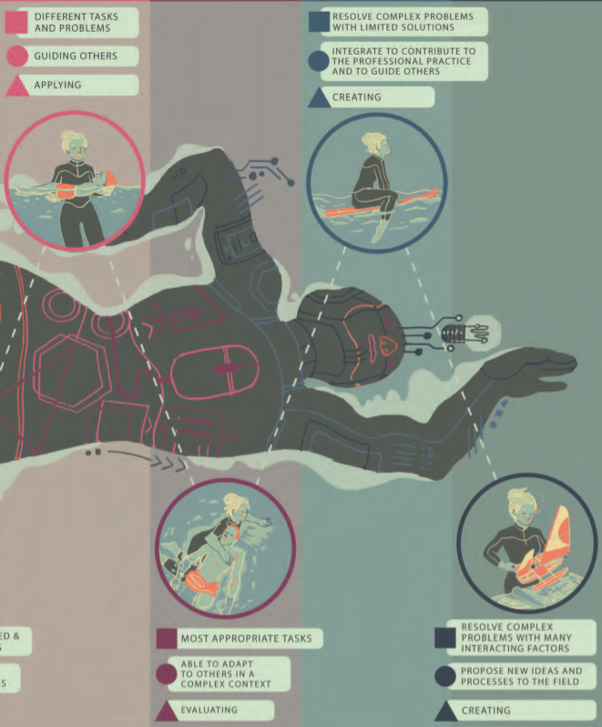

Figure 3 JRK Competence framework for citizens (source: DigComp 2.1, 2017, p. 15)

EntreComp describes entrepreneurship as a lifelong competence, identifies what are the elements that make someone entrepreneurial and describes them to establish a common reference for initiatives dealing with entrepreneurial learning.

The EntreComp model includes the following basic competences (Bacigalupo, Kampylis, Punie, & Van den Brande, 2016):

* Spotting opportunities, that is the ability to identify opportunities for creating value by exploring the social, cultural and economic landscape as well as the capacity to identify needs and challenges create value.
* Creativity, that is the skill to develop creative and purposeful ideas to create value, including better solutions to existing and new challenges as well as to combine knowledge and resources to achieve valuable effects.
* Vision , that is the capacity to imagine the future and develop a vision to turn ideas into action.

Computational thinking (CT) is a central ability to tackle the impact of the digital revolution.

CT is the ability to use the concepts of computer science to formulate and solve problems. According to Wing, thinking computationally is a fundamental skill for everyone, not just computer scientists. Indeed, CT is a method of analytical thinking that encompasses many skills, such as designing algorithms, decomposing problems, and modeling phenomena. It can take place without a computer since it is “a way of solving problems, designing systems, and understanding human behavior that draws on concepts fundamental to computer science” (Wing, 2006, p. 35).

To support the acquisition of digital skills and competences, appropriate teaching-learning strategy should be defined and experimented. On this purpose, transformative learning has becoming an increasingly popular practice in a variety of educational settings, including higher education, professional education, and community education.

Indeed, individual learning styles (e.g., visual, auditory, kinesthetic) impact learners’ preferences and results, whilst there is evidence that people’s experiences of digital education are patterned distinctly in relation to social class, race, and disability. As such, online learning environments do not unproblematically reduce differences between individuals.

**Learning models supporting the new educational needs**

The Mezirow’s transformative learning theory can support the professionalization of workforce.

 Mezirow introduced the concept of transformative learning in a study based on 83 women returning to college in 12 different reentry programs (Mezirow, 1975).

Mezirow initially described a process of personal perspective transformation that included 10 phases. Since that time, the concept of transformative learning has been a topic within the area of adult learning and education.

Transformative learning theory is largely based on constructivist assumptions.

Constructivism asserts that learning is contextual.

The Mezirow’s ten phases:

1. A disorienting dilemma
2. A self-examination with feelings of guilt or shame
3. A critical assessment of epistemic, sociocultural, or psychic assumptions
4. Recognition that one’s discontent and the process of transformation are shared and that others have negotiated a similar change
5. Exploration of options for new roles, relationships, and actions
6. Planning a course of action
7. Acquisition of knowledge and skills for implementing one’s plan
8. Provision trying of new roles
9. Building of competence and self-confidence in new roles and relationships
10. A reintegration into one’s life on the basis of conditions dictated by one’s perspective

**The Mezirow’s disorienting dilemma**

A disorienting dilemma is the catalyst for perspective transformation. Dilemmas usually occur when people have experiences that do not fit their expectations or make sense to them and they cannot resolve the situations without some change in their views of the world.

A disorienting dilemma occurs when an individual is provided with or experiences disconfirming evidence that offers an alternative perspective and causes this individual to question deeply held beliefs.

Indeed, we do not learn isolated facts and theories in an abstract, but we learn in relationship to what else we know, what we believe, our prejudices, and our fears.

Learning is an active and social process. We cannot separate our learning from our lives.

We develop or construct personal meaning from our experiences and validate it through interaction and communication with others (Cranton, 2006).

In the transformative learning perspective, learning is voluntary in that the learner must be willing to engage in critical self-reflection. Accordingly, learners should be self-directed to be aware of their beliefs and assumptions, as well as to actively participate in discussion related to their self-analysis.

According to Mezirow, transformative learning can also include sharing experiences with others.

The author argues that the goal of adult education and transformative learning is “to help adult learners become more critically reflective, participate more fully and freely in rational discourse and action, and advance developmentally by moving toward meaning perspectives that are more inclusive, discriminating, permeable, and integrative of experience” (1991, pp. 224–225).

Transformative learning has become the dominant teaching paradigm discussed within the field of adult education and has become a standard of practice in a variety of disciplines and educational settings, including higher education, professional education, organizational development, international education, and community education.

According to Mezirow (2000), we view the world through a web of assumptions and expectations described as a frame of reference that consists of two dimensions—habits of mind and the resulting points of view, or assumptions.

Habits of mind include our ways of learning, sociocultural background and language, our psychological nature, moral and ethical views, religious doctrine or worldview, and how we view beauty (Mezirow, 2000). They are absorbed from our family, community, and culture (Cranton, 2006). Beliefs, assumptions, and expectations arise from an individual’s habits of mind.

According to Mezirow (2000), we view the world through a web of assumptions and expectations described as a frame of reference that consists of two dimensions—habits of mind and the resulting points of view, or assumptions.

Habits of mind include our ways of learning, sociocultural background and language, our psychological nature, moral and ethical views, religious doctrine or worldview, and how we view beauty (Mezirow, 2000). They are absorbed from our family, community, and culture (Cranton, 2006). Beliefs, assumptions, and expectations arise from an individual’s habits of mind.

Assumptions are personal and variable. They shape our expectations, perceptions, understandings, and feelings, and therefore, our actions. Assumptions play an influential role in actions by filtering and directing attention, guiding choices, and interpreting the meaning of an act or experience (Mezirow, 2000). Mezirow (1991) asserted that there is overwhelming evidence to support the idea that we tend to accept and integrate experiences that comfortably fit our frame of reference. Ultimately, our unique points of view are a combination of interwoven beliefs, assumptions, values, feelings, and expectations that have arisen from our habits of mind.

**Teaching-learning in a digital environment**

Nowadays, online education has become an increasingly important part of tertiary education and takes two primary forms. The first consists of for-credit courses offered by higher education institutions. The second form of online education consists of professional training and certification preparation.

An online learning environment is characterized by the use of the internet to access learning materials and interact with contents, teachers, and other students. Online learning should allow time and space for independent learning, enabling learners to progress at their learning speeds.

The primary learning models in an online environment are blended learning and digital social learning.

Blended learning combines e-learning with traditional classroom method (face-to-face learning) while digital social learning is an approach where an individual achieves their learning goals by accessing learning resources available online as well as interacting on the internet with teachers and other learners.

Blended learning is a formal education program in which a student learns through, at least in part, online tools. Essentially, it is the combination of two historically separate teaching-learning models: traditional face-to-face learning systems and distributed learning systems. In blended learning, computer-based technologies play a central role (Figure 4).

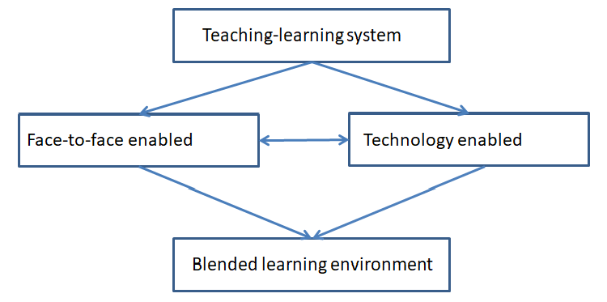

Figure 4. The blended learning model (authors’ own source)

In the last few years, as a consequence of the spread of digital technologies, digital social learning is assuming a strategic role in the online learning scope. In an effort to alleviate critical aspects due to poor interactive capability and asynchronous scheduling, some e-learning platforms such as BlackBoard and Moodle began to incorporate digital social learning components (chat and virtual classroom). Nowadays, most of the platforms allow interaction between students (through user-generated posts/comments) and provide question asking and answering functions.

Figure 5 shows the digital social learning model.

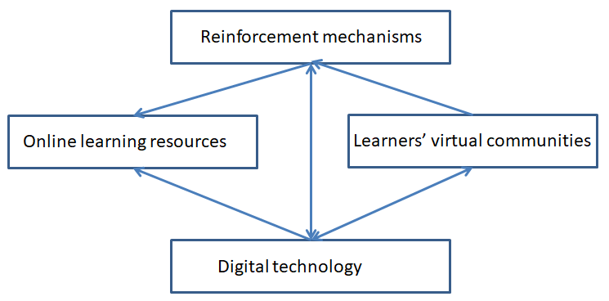

Figure 5. The digital social learning environment (authors’ own source)

The massive abundance of online contents also suggested new forms of self-learning activities. Accordingly, new opportunities and challenges arise.

**A multidimensional teaching-learning approach**

According to transformative learning theory, we develop and construct personal meaning from our experiences, and validate it through interaction and communication with others (Cranton, 2006).

Learning is a social process. We do not learn isolated facts and abstract theories but, rather, we learn in relationship to what else we know, to what we believe, to our prejudices, and to our fears. Moreover, there is a broad consensus the learning is socially constructed (Bruner, 1976; Vygotsky, 1980).

learners are not passive receivers of knowledge since learning is a social activity. This concept is on the basis of the socially situated learners by Lave and Wenger (1991). They argue that knowledge and skills should not be seen as solely belonging to an individual but things which are to be shared and developed collectively. The social, political, economic and cultural dimensions of any community of practice and the nature of interactions between members determine how much learning occurs. What is important for the authors is that learners have a common interest and share practices.

In this perspective, it is advantageous integrating Mezirow’s transformative learning and Bandura’s social learning theory.

A multidimensional approach could be appropriate to support the lifelong leaning needs and meet the necessity of different audience.

From Bandura’s theory (Bandura, 1977), two fundamental principles should be included in the multidimensional model:

* Intrinsic reinforcement, which provide learners with a reward that is derived internally and gives them a sense of accomplishment and satisfaction.
* The gain of knowledge through participating and interacting with others, since learning is reinforced through observing the behavior of other individuals.

These principles, included in a transformative learning approach, should allow learners to achieve their learning goals, also in an online environment.

Participatory learning and peer learning are increasingly appealing as educational approaches that can positively affect adult learners since they engage them as active participants in educational programs (Topping, Buchs, Duran, & Van Keer, 2017).

Participatory learning and peer learning could help cultivating critical thinking and sustaining the disorienting dilemma that is the first step in transformative learning (Provident et al., 2015). A disorienting dilemma occurs when an individual is provided with experiences that disconfirm evidence and which offer an alternative perspective, causing the individual to question their own previously deeply-held beliefs. Participatory learning and peer learning could support learners helping them to interpret their experience and learn to overcome their biases. Figure 6 shows how observation and interaction with other learners could facilitate engagement in critical reflection, bringing beyond biased assumptions.

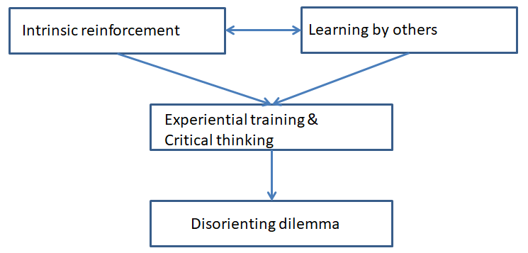

Figure 6. Learning by others and intrinsic reinforcement as key factors for generating the disorienting dilemma.

**Conclusion**

If the integration of transformative learning and social learning can bring to an effective approach for adult learners, how can we create an online multidimensional learning environment to corroborate online adult education practices?

The potential of digital technology is enormous, and can allow the creation of massive teaching-learning programs. Learners will be able to learn at their own pace, and non-formal and informal learning activities will be advantaged. Companies will increase their business by continuously re-training their workforce, while workers can retain and safeguard their jobs and careers by improving their range of skills and competencies.

Digital technology will generate changes in the scope of education, making new things possible but, at the same time, introducing new issues and challenges.

To find appropriate solutions to teaching-learning in the digital era, we ought to know how to use the technology in innovative way. In this perspective soft skills such as critical thinking and creativity can play a crucial role. In a future in which learning activity will accompany people during their life, we need new forms of motivation that can sustain the learners’ effort.

This is a challenging aspect of teaching-learning that require experiments and research investments.

**References**

Bacigalupo, M., Kampylis, P., Punie, Y., & Van den Brande, G. (2016). EntreComp: The entrepreneurship competence framework. *Luxembourg: Publication Office of the European Union*, 14.

Bandura, A. (1977). Social learning theory.  General Learning Press.

Basadur, M. (1997). Organizational development interventions for enhancing creativity in the workplace. *The Journal of Creative Behavior*, *31*(1), 59-72.

Basadur, M. (1998). The Basadur Simplex creative problem-solving profile inventory: Development, reliability and validity. Available at: <https://macsphere.mcmaster.ca/bitstream/11375/5385/1/fulltext.pdf>; last accessed 8.13.2019.

Beale, R. (2007). Supporting serendipity: Using ambient intelligence to augment user exploration for data mining and web browsing. International Journal of Human-Computer Studies, 65(5), 421–433.

Boden, M. A. (1996). Creativity. In *Artificial intelligence* (pp. 267-291). Academic Press.

Boden, M. A. (1998). Creativity and artificial intelligence. *Artificial Intelligence*, *103*(1-2), 347-356.

Bria, F., Sestini, F., Gasco, M., Baeck, P., Halpin, H., Almirall, E., & Kresin, F. (2015). Growing a digital social innovation ecosystem for Europe: DSI Final Report. *Brussels: European Commission*.

Bruner, J. (1976). Learning how to do things with words. *Psycholinguistic research*, 265-84.

Cranton, P. (2006). Fostering authentic relationships in the transformative classroom. *New Directions for Adult and Continuing Education*, *2006*(109), 5-13.

Deloitte Global & GBC-Education (2018). Preparing tomorrow’s workforce for the Fourth Industrial Revolution, For businesses: A framework for action. Available at: <https://www2.deloitte.com/content/dam/Deloitte/global/Documents/About-Deloitte/gx-preparing-tomorrow-workforce-for-4IR.pdf>; last accessed 7.25.2019.

Education Commission. (2017). A Proposal to Create the International Finance Facility for Education. *New York, The International Commission on Financing Global Education Opportunity*. Available at: <https://report.educationcommission.org/wp-content/uploads/2016/09/Learning_Generation_Full_Report.pdf>; last accessed 8.21.2019.

Enders, T., Hediger, V., Hieronimus, S., Kirchherr, J. W., Klier, J., Schubert, J., & Winde, M. (2019). Future Skills: Six Approaches to Close the Skill Gap. *World Government Summit*.

Gibert, A., Tozer, W. C., & Westoby, M. (2017). Teamwork, soft skills, and research training. *Trends in ecology & evolution*, *32*(2), 81-84.

Lave, J., & Wenger, E. (1991). *Situated learning: Legitimate peripheral participation*. Cambridge university press.

McGrath, E. M. (2018). *Autonomous vehicles: opportunities, strategies and disruptions*, Independently published.

Mezirow, J. (1975). Last Gamble on Education: Dynamics of Adult Basic Education.

Mezirow, J. (1991). *Transformative dimensions of adult learning*. Jossey-Bass Publishers.

Mezirow, J. (2000). *Learning as Transformation: Critical Perspectives on a Theory in Progress. The Jossey-Bass Higher and Adult Education Series*. Jossey-Bass Publishers.

Provident, I., Salls, J., Dolhi, C., Schreiber, J., Mattila, A., & Eckel, E. (2015). Design of an Online Curriculum Promoting Transformative Learning in Post Professional Doctoral Students. *Online Learning*, *19*(3), 128-143.

Runco, M. A., Pritzker, M. A., Pritzker, S. R., & Pritzker, S. (Eds.). (1999). *Encyclopedia of creativity* (Vol. 2). Elsevier.

Taylor, C. W. (1988). Various approaches to and definitions of creativity. *The nature of creativity*, 99-121.

Topping, K., Buchs, C., Duran, D., & Van Keer, H. (2017). *Effective peer learning: From principles to practical implementation*. Routledge.

University of Phoenix (2011). Life in the 21st Century Workforce: A National Perspective. Availabe at: <https://www.uschamberfoundation.org/sites/default/files/publication/edu/Life%20in%20the%2021st%20Century%20Workforce.pdf>; last accessed 7.24.2019.

Van Holm, E. J. (2015). Makerspaces and contributions to entrepreneurship. *Procedia-Social and Behavioral Sciences*, *195*, 24-31.

Vygotsky, L. S. (1980). *Mind in society: The development of higher psychological processes*. Harvard university press.

Wing, J. M. (2006). Computational thinking. *Communications of the ACM*, *49*(3), 33-35.



**THE NATIONAL CONTEXT OF SOCIAL EDUCATORS IN SPAIN**

**DEFINITION OF SOCIAL EDUCATOR.**

According to the basic principles regulating the professional practice of the social educator, in accordance with the statutes of the Professional Association of Social Educators of the Valencian Community, in Spanish: Colegio Profesional de Educadoras y Educadores Sociales de la Comunidad Valenciana (COEESCV), the following definition of social educator is established:

The Social Education is a pedagogical profession that, at the service of the compliance with the fundamental values ​​of a Rule of Law and through mediating and formative actions, promotes sociability, social circulation and the cultural meeting of people or groups.

Social educators are professionals who support and protect people at risk of social exclusion. The main objective is to improve the integration of especially vulnerable groups by promoting their active participation in society. Social educators work with citizens of very different profiles, from young people with few economic resources, to people with disabilities or the elderly with a scarce support network.

**REGULARIZATION OF THE PROFESSION IN SPAIN. LEGAL SCOPE.**

Social educators are those who develop their profession in activities of Social Education as provided by Royal Decree 1420/1991 establishing the Official University Diploma in Social Education and Royal Decree 1393/2007, of October 29, by which the organization of university education is established and the Degree in Social Education is created.

Regarding to the regularization of the profession in Spain, the most common way to become a social educator is the University Degree in Social Education. It is a curriculum divided into 4 academic years and 240 ECTS credits.

At present, the Social Education career has a high demand for access, so that more and more students decide to study Social Education in Spain.

*International Relations Department.*

*Mancomunidad de la Ribera Alta, Alzira (Spain).*

**BIBLIOGRAPHY**

* COEESCV (2015). Estatutos del Colegio Oficial de Educadoras y Educadores Sociales de la Comunidad Valenciana. Valencia, España. Disponible en: <https://www.coeescv.net/coeescv/estatutos.html>

gilberto

Descripción breve

[Dibujar su lector con un resumen de la participación. Normalmente es un breve resumen del documento.   
Cuando esté listo para agregar contenido, haga clic aquí y empiece a escribir.]

**INDEX.**

**1. INTRODUCTION.**

**2. LIST OF DSI INITIATIVES/ACTIVITIES IN SPAIN:**

**2.1. PROFESSIONAL USE OF ICT IN INTEGRACION.**

**2.2. ICT APPLIED TO FUNCTIONAL DIVERSITY.**

**2.3. ONLINE FORMATION (SOCIAL COACHING).**

**2.4. DIGITAL NEEDS.**

**2.5. TELEMATIC REHABILITATION/ONLINE PROGRAMS PARENT TRAINING.**

**3. CONCLUSIONS.**

**4. BIBLIOGRAPHY.**

**DSI PROJECT. ERASMUS+.**

**“Digital social innovation: new educational competences for social inclusion”.**

List of DSI initiatives/activities in Spain.

**1. INTRODUCTION.**

Over the past few years, all areas of citizenship have been modified by the technological changes that have taken place. An example is found in the scope of work, where the ways of understanding occupations have been affected by the forms of production, given that they have been technified to originate new professional conceptions. The educational sphere has also been altered by reformulating regulations, methodologies and teaching-learning processes, so it can be argued that nowadays, the generation of knowledge depends to a large extent on the ability to organize society to take advantage of the benefits of the new technological system.

In fact, communicative and informational technologies have had a development explosive in the last part of the 20th century and the beginning of the 21st century, to the point that they have shaped what is called “The Knowledge or Information Society”. This context implies a new perspective in educational systems, corresponding to them training in the acquisition of skills and abilities to manage information and new knowledge. In conclusion, the incorporation of technological resources in educational centers promotes new ways of generating knowledge and, on the other hand, values ​​and attitudes that improve the globalized society in which we live, where the role of the social educator takes on a greater role.

The document below exposes a review, through the consultation of different sources of information, of all the initiatives and activities that are being developed in digital social innovation in Spain. It also includes the effects and results of implementing this kind of measures in social scope. The information comes from some articles by different authors of the country that have been consulted to carry out this review, where we’re going to focus on some topics about DSI, which are **the professional use of ICT in integration, the ICT applied to functional diversity, the online formation (social coaching), the digital needs and the telematics rehabilitation/online programs parent-training.**

**2. LIST OF DSI INITIATIVES/ACTIVITIES IN SPAIN.**

**2.1.** **PROFESSIONAL USE OF ICT IN INTEGRATION.**

Firstly, in this review is going to be explained the professional use of ICT in integration. In this paragraph the review focuses on the consultation of articles on ICT and the relationship of these tools with the social education in today’s society. On the other hand, in the document are also explained some good practices with ITC according to different studies and researches, and the effects and results of using ICT in the professional field to achieve social integration.

In an article written by Begoña E. Sampedro from the University of Córdoba (Spain, 2015), called “ICT and social education in the twenty-first century”, it contains a series of thoughts on the role played by professionals of social education in new social realities, in which underlies the necessity of a formation and training of technological resources as elements that promote integration of subjects in community. As a result of this assumption, presents a brief theoretical analysis of the social education in the XXI century stopping at two main elements, university degree that develops and basic characteristics of professional occupation which perform. Also, is recounted the elements that determine today’s societies, approaching technology as a basic component of these new realities.

**ICT and Social Education.**

First of all, to understand the professional use of ICT in integration, it’s important to understand the relationship between ICT and Social Education. The praxis of professional occupation promoted by Social Education is fundamentally the socialization of the individuals, promoting actions aimed at promoting the incorporation of people to society in a dynamic and competent manner; this fact infers the conscience of the professionals, dedicated to this field, of the aspects that intervene in the obtaining of this purpose; among them, the incorporation of ICT is influencing, taking into account that the presence of ICT is reaching all sectors of our society, from culture and leisure, to industry and training institutions; and on the other, that no one sees them as an added element to the educational system, but as meaningful means for learning, school innovation environments, and for communication and social interaction.

Individuals must integrate technology into their usual actions, becoming familiar with and using it, as a consequence they will understand their nature and the potential they provide; this goal, in Europe, is one of the seven initiatives proposed by the European Commission (2010) in the Strategies for smart, sustainable and inclusive growth for 2020, so these actions promote the acquisition and development of competition digital in all citizenship.

The incorporation of the Social Educator into the educational system, as one of the professional alternatives that it enjoys, benefits these requirements that are required of education, attending to the training of this professional to carry out his work of socialization in the environments educational, enabling a triple slope, in its socio-educational activities: towards the student to whom it directs, towards the public and private organizations with which it collaborates and towards the rest of the team with which it cooperates: they will be favored with the digital incorporation.

Regarding the fundamental action of the Social Educator, not only the acquisition of digital competence becomes an essential element for inclusion in society but also the development of technological literacy, from which the digital divide arises as a social aspect. The digital divide hinders the development of the basic principles of education by producing exclusion; at the same time, the basic principles of socialization by obstructing interaction and communication, both with peers and with the rest of society; becoming an inhibiting aspect of personal well-being; consequently, it must be considered by the social educator as a possible situation of risk and marginality for the students.

In conclusion, the agents dedicated professionally to the field of the social intervention can’t obviate the technological resources for the exercise of their functions; consequently, they must know the advantages and limitations that its application implies, as well as the non-use of them, considering that the latter may cause the social unadaptability of the individual in the citizenship.

**Good Practices with ICT in integration.**

In this paragraph are going to be exposed some good practices with ICT according to different studies and researches about the professional use of ICT in integration.

* **The Research Excellence Project “Best Practices in integrating ICT in Primary and Secondary Schools of Andalucía”, by Ángel Boza and María de la O Toscano from the University of Huelva, (Spain, 2011).**

Firstly, according to the Research Excellence Project “Best Practices in integrating ICT in Primary and Secondary Schools of Andalucía”, developed by Ángel Boza and María de la O Toscano from the University of Huelva, which is a multiple case study that present two cases of Primary Schools to describe and interpret best practices in ICT integration, it’s pretended to show the impact of the professional use of ICT in integration. In this project have been used various qualitative strategies (open interviews, participant observation, document analysis, audiovisual recordings…), in order to offer a rich, multidimensional, optimistic and critical portrait of ICT impact in education.

The project is based on the study of two cases of primary schools, CEIP Abencerrajes and CEIP San Walabonso. On the one hand, the CEIP Abencerrajes, located in the town of Granada, has a unifying ICT Project, which understands both teachers and families. Regarding ICT resources, it has the Helvia platform, an institutional platform used partially and structured in three elements: website, blog and virtual classroom. It also has a web page with resources available for teachers.

As for the educational materials, they carry out the elaboration and re-elaboration of their teaching materials, elaborated in three formats: paper format, digital format and web format. Among the students, cooperative work is encouraged in the classroom and work with laptops from the classroom itself.

On the other hand, CEIP San Walabonso, located in the town of Niebla, located southeast of the province of Huelva, has an ICT Project of the management team, as well as a website of the center with a simple structure, which offers information and educational experiences, informs about the TIC Project and facilitates the information about contents and works carried out during the course. It also offers and generates teaching resources based on ICT to other teachers. The center uses ICT to develop their own educational materials, and both students and teachers participate in the design of these materials. Cooperative work is encouraged among the students and, in addition, they have the ICT classrooms.

Regarding the conclusions of the project about the introduction of ICT in educational processes, are pointed out the following aspects;

* The development of a center project involving the whole educational community: teachers, students and parents.
* It generates, or at least increases, team awareness among teachers. They have adopted collaborative strategies to solve problems and advance the use of ICT resources in the classroom.
* The improvement of information, but above all of communication, between teachers, between students and teachers, between students and between the center and families.
* Certain changes in the learning model. There is a clear tendency to cooperative learning, group work for projects and, ultimately, learning processes built by students in collaborative environments in which the teacher plans and guides learning situations.
* The academic motivation of the students increases, fundamentally by the new vehicle-support of the tasks, but also by the investigative focus of the same. Likewise, teacher motivation also increases, for which the integration of ICTs is a technological challenge first and methodological later. This motivation of the teachers, described as enthusiasm, previous in some teaching teams aware of the potential of ICT, is transmitted and transmitted to other teachers, students and families.
* Collaborative culture, true teaching teams, involved management teams and facilitators, fluid communication and information and shared decision making. At the classroom level, work by team projects and the cooperative organization in terms of materials and resources predominate.
* The involvement of the educational community is high, the centers are open to the community, which is informed and heard and participates in academic activities specifically designed for it.
* The attitude towards ICT, initially reluctant due to fear and lack of technological training, has been changing to positive. ICTs are recognized as a need and a current reality that the school must face.

In conclusion, after observing the results obtained in the study, there is a direct relationship between the professional use of ICT, in this case in the educational context, and the social integration of students, teachers, families and the educational community in general. After observing the impact of the results of this project, we can conclude that:

* Introducing an ICT project in an educational process can involve all the members of the educational community by improving the integration of all these agents in the educational context.
* The use of ICT increases the collaborative culture in the centers.
* The use of ICT improves the information and the communication between all the members of the educational community.
* The use of ICT promotes the need of training activities and strategies focused on teachers oriented to technological training.
* Introducing the ICT increases the motivation of the students, teachers and families.
* The use of ICT promotes an educational climate in which teamwork and cooperative organization predominate.
* The ICT are considered as an educational necessity and as a reality in the school context.
* **The IMPOLIS research project: “Digital literacy in Spain as a means of social inclusion: implementation of a measurement model using indicators”, by Mercedes Caridad Sebastián, Ana María Morales and Fátima García, from the University Carlos III of Madrid, (Spain, 2013).**

Secondly, according to other article called “Digital literacy in Spain as a means of social inclusion: implementation of a measurement model using indicators”, developed by Mercedes Caridad Sebastián, Ana María Morales and Fátima García, from the University Carlos III of Madrid, it is described that through the application of the measurement model developed in the project “IMPOLIS”, an analysis of data on the impact of ICT policies established in relation to issues of social inclusion is proposed.

The IMPOLIS research project aims to develop a model for measuring the impact of ICT policies, that can be employed to guide efficient decision making for harmonious and sustainable development of the Knowledge Society. In this research the regions with the lowest GDP per capita in the Spanish territory were selected, in relation to the matters specified in the project of the effectiveness of ICT policies, and a representative sample of the target groups (*women, elderly, unemployed, disabled, people suffering from illiteracy, immigrants*) by geographical areas.

The scorecard indicators (scoreboard) for the model focuses on three categories or dimensions of study, *Social Infrastucture ICT Competence and Level Appropriation Competence*, in turn divided into several sub-categories of analysis. The results obtained in this study allow a first checking of the validity of the proposed measurement proposed by the IMPOLIS Project, as a monitoring tool for ICT policies. The proposed method allows to design and redirect measures for reducing the digital divide, and to consolidate a model of social inclusion through digital inclusion in line with the current EU measures.

The IMPOLIS Project: “Indicators for the measurement of the impact in ICT policies towards social inclusion”, funded by the Ministry of Science and Innovation, has made it possible to develop and test a model for measuring the impact of ICT policies, which can be used to in order to guide efficient decision-making for the harmonious, inclusive and sustainable development of the Knowledge Society.

In line with the objectives proposed in the project in the “Comparative analysis of results and action proposals” phase, in this study an analysis of the obtained data has been carried out, which has made it possible to test the effectiveness of the evaluation model and make proposals of action in relation to public policies aimed at promoting social inclusion through ICT.

In terms of methodology, Phase 1 of the IMPOLIS project identifies and proposes target groups at risk of exclusion (elderly women, the unemployed, disabled, population suffering from illiteracy, immigrant population), on which the proposal of a Evaluative Model to measure the effectiveness of ICT policies for digital and social inclusion.

To verify the validity of the model, this research selected the two Autonomous Communities (Autonomous Communities) with the lowest per capita GDP in Spain: Extremadura (GDP = 15.3) and Andalucía (GDP = 16.9) (INE, 2012). The Tele-centers, are public spaces that allow free access of citizens to ICT, so it was considered that they would be the most suitable places to carry out research in the selected Autonomous Communities. Finally, 19 telecentres participated, a measure proportionally adjusted to the number of inhabitants of the two autonomous regions: 16 telecentres in Andalusia and 3 in Extremadura. Surveys were conducted in these Autonomous Communities throughout 2012, which were completed by 85.5% of the population expected in the sample, users of a total of 19 telecentres, located in populations of less than 5,000 inhabitants. of the two autonomous communities. The purpose of these surveys was to analyze the results of the study around the following areas of evaluation: Sociodemographic and Socioeconomic Characteristics of the target groups; ICT Social Infrastructure: availability, intensity, purpose of uses and barriers to use; Competent Appropriation and Competence Level.

Once the study was completed, the following aspects were concluded:

* The applicative validity of the proposed model is confirmed, indicating recommendations that would help complete the research, such as taking into account the disparate characteristics of the different target groups in terms of training, knowledge of ICTs and economic level.
* The model is aimed at making decisions about future action proposals aimed at promoting social inclusion in Spain. The research highlights the relevance acquired by the competencies related to access, management and use of information, as a means to prevent the difference existing in the degree of appropriation of ICTs becoming a new and powerful “class marker” in sectors of already vulnerable populations (groups at risk of exclusion).

BUSCAR SOBRE:

-alfabetización digital e integración social en España.

-ejemplos de buenas prácticas con TIC para la integración social en España

**2.2. ICT APPLIED TO FUNCTIONAL DIVERSITY.**

Among the aspects on which this analysis focuses, one of them consists of the use of ICT applied to functional diversity. According to the World Health Organization (WHO, 2016), disability is a generic term that covers deficiencies (problems that affect a body structure), activity limitations (difficulties in performing actions or tasks) and restrictions on participation (problems to participate in life situations). Consequently, disability is a complex phenomenon that involves an interaction between the characteristics of the human organism and those of the society of which it is a part.

Currently, there are over one billion people in the world with some type of disability, which represents approximately 15% of the world’s population, according to the estimates of the World Report on Disability (WHO and World Bank, 2011). It is also a problem that is increasing, due to the aging of the population and the increase of chronic health problems, which disproportionately affects the most vulnerable populations.

In addition, today’s society is characterized by a social reality in which digital media and resources are becoming increasingly important, and in which digital literacy is considered as a useful tool for the development of necessary skills and abilities for the overcoming of barriers to accessibility to ICT by people with functional diversity. For this reason, this analysis aims to show different examples of good practices in terms of the use if ICT applied to functional diversity.

**Good practices with ICT applied to functional diversity.**

In this paragraph are going to be described some good practices of ICT applied to functional diversity in the country of Spain.

* **“ICT in the service of inclusive education”, by Marisol Rodriguez from the University of Coruña, and Maria José Arroyo from the University of Valladolid, (Spain, 2014).**

Firstly, according to an article called “ICT in the service of inclusive education” developed by Marisol Rodriguez from the University of Coruña, and by Maria José Arroyo from the University of Valladolid, there is a revision on the different Technologies of the information and of the Communication to work with pupils with educational special needs. In this article ICT are postulated as a suitable instrument to obtain the access of the whole student body to the general education and how to overcome the different barriers of learning which they face every day vehicle. In this work, the article is focused on the different tools and specific software for the visual, auditory, motorboat and cognitive disabilities.

**ICT and students with visual disability.**

Regarding ICT and students with visual disabilities, ICT is currently the most important resource for people with visual disabilities to access information and perform reading and writing tasks, therefore the development achieved by computer technology, is essential for these people to be included in society of information and in the world of work, achieving autonomy for the development of their tasks (Zappala, Koppel and Sushodolski, 2011). The Tiflotechnology Toflological materials are defined as those traditional instruments, specific or adapted, non-electronic (yellow stripe, pattern, punch, arithmetic box, Perkins machine, abacus, cane, etc.) that enable the blind visually impaired access to educational, social and labor world. The Organización Nacional de Ciegos Españoles (ONCE), through the Tiflotécnica Unit, is responsible for the evaluation, import and repair of special devices and materials, as well as to encourage research and manufacturing in Spain of the Prototypes that are estimated more appropriate and necessary. This Unit also recycles technical instruments so that they are updated.

***Low level adaptations***

The low level adaptations are those systems of access to digital information designed for blind or low vision people, which are structured into three subcategories:

Image enlargement: it is useful only for people with visual remainder, whether it is a lot or a little, this method consists in enlarging the characters and other contents of the screen from double to sometimes very high levels.

Voice synthesis: where the group of blind people or people with low vision is included, its objective is simply to send information from the computer to the user through spoken messages, which are usually issued with totally or partially synthetic voices although in some cases they can be use recorded voices Some of the devices with voice synthesizer are: special tape recorders, briallex, versabraille and the Kurzweil reading machine.

Braille output: this subcategory incorporates the two deaf-blind groups. The Braille System, developed by the French teacher Louis Braille, is the universal method of reading and writing for the blind, and thanks to it the blind can read books, take notes and follow basic studies or university careers as anyone.

***High-level adaptations***

High-level adaptations are all those applications whose results are obtained through one or more of the low-level adaptations, thus requiring the presence of any of these to perform their task. In relation to the quality of information that they process, we can group them in the following way:

-Screen reviewers: it is the most important and old group of high level adaptations, it is made up of all the programs and controllers that extract the information from the video card of the computer transmitting it to the user after a process of analysis, artificial assumption and deciphering. Among them we have: the image enlargers (programs designed to increase the size of the images displayed on the screen) and the screen readers (programs that serve as an interface between the video card, the speech synthesis systems and / or the terminals of reading Braille and the user of the computer who expects to obtain from them the reading or interpretation of the maximum possible of elements that make up the screens of each work environment).

-Document reviewers: those applications that seek information by transmitting to the user through low level adaptations, directly in computer files located on a disk, remote computer or other similar support, or a peripheral capable of transmitting equivalent data. Some of them are: document readers, character recognizers, Internet browsers, digital spoken books.

-Note takers: they are easy to carry, use and very useful systems for people who do not see enough to take notes in a conventional way.

**ICT and students with hearing disability.**

People with hearing disabilities are all those people who have a hearing loss or decrease to a greater or lesser degree. People with hearing impairment constitute a quite heterogeneous group according to their characteristics, type and degree of deafness, moment of detection of it, age at which the use of hearing aids begins, learning capacity, family support and the system of employee communication: oral language / sign language. Therefore, for the group of people with hearing disabilities, the visual channel and the visual experience play a predominant role in their development and in their life experience.

***Technological resources regarding the stimulation of auditory remains.***

-Hearing aids or individual hearing aids: the hearing aid is a technological element that acts on the sound stimulus, not on the auditory organ. A hearing aid or hearing aid is a simple amplifier that has a retroauricular and intraauricular placement (in the pavilion of the ear), with increasingly sophisticated systems that encode and convert the electric current coming from the amplifier into more noticeable acoustic signals.

-Autonomous sound amplification equipment by frequency modulation: they are the devices that allow to reduce the noise interference of the environment and eliminate the distance between emitter and receiver, allowing the mobility of teachers and deaf students.

* *FM Easy Listener system:* provides a solution with mobile equipment and without the need to make structural changes in the classrooms. The FM system provides a direct transmission from the transmitter used by the teacher to the receiver used by the student, since the microphone of the transmitter is located below the chin, physical distance is no longer a problem.
* *SUVAG-1:* it is a device for individual or group work, which is designed with a double system of filters, high-pass and low-pass, plus a somnato-sensory transmission system through the vibrator. With the Suvag rehabilitation the master ideas of the verbotonal method become reality in the students: development of the auditory perception, development of the linguistic conscience through the unconscious structuring based on operative conducts, the situational work, the recourse to keys not exclusively verbal, the importance given to the human factor, etc.

-Computer programs: These are programs for students with special educational needs that must comply with general ergonomic criteria (suitability of the design, adaptation of contents at different levels of difficulty, progressive aid system, evaluation of the execution, etc.). The programs for the visually impaired should have some variants such as: modality of visual presentation for all the sound communications of the program, level of vocabulary appropriate to the lexical-semantic knowledge of the student, visual images as the main means of communication, introducing some alternative / augmentative system to the speaks when it is essential, quality and effectiveness of the screens, programs with open design and multiuser.

* *Speech viewer-III (SV3):* is a powerful and flexible tool, which combines clinical management with intervention aimed at increasing efficiency in speech rehabilitation and which allows: visualizing the physical parameters of articulated sound, educating breathing, facilitate training in phonological oppositions, represent articulatory tension, visualize and train syllabic, phonetic and segmental segmentation, improve prosody by making speech more intelligible, facilitate on-screen comparison of colloquial speech emissions, etc.).
* *The speech visualizer (VISHA system):* it is a package compounded of hardware and software developed in the department of Elcentronic Engineering of the Polytechnic University of Madrid, for the rehabilitation of the speech by means of graphical real time representation of the parameters of the vocal sign. This program contains, in an alone package, different systems for some other tasks as the study of the voice, evaluation of the hearing, rehabilitation of speech, synthesis of voice, reading learning, etc. The program includes a module to convert text to voice by means of synthesis of voice.
* *Orthophonic collars:* It is an application for the trainingin physical parameters of the articuled sound, more specifically intensity and duration. The principal advantage of this program is that physically manipulable elements, cylinders and wooden balls can be integrated, with virtual elements on the computer screen.

There are other important computer programs such as the LAO Project (Computer-Aided Speech Therapy) that is used for the development of oral and written language in deaf students, and programs for the development of literacy such as the BabeWin (designed to process symbols of the alphabet or graphs, both individual and grouped).

**ICT and students with motor disability.**

Motor disability is that handicap, in the upper and lower limbs, which generally involves problems of displacement and usually problems of manipulation. It is seen in people suffering from paraplegia, tetraplegia, cerebral palsy, muscular dystrophies, lateral or multiple sclerosis or partial hemiplegia. These students present a diversity of needs such as the acquisition, development and use of oral and written language, comprehensive and expressive; alternative or augmentative communication systems, development of perceptual, sensorimotor and cognitive capacities; acquisition of behavioral repertoire and social skills and personalized attention through adaptations of access to the curriculum. In the last decade we have found a range of aids for communication and access systems, particularly ICT have made it possible for some people with motor disabilities to communicate.

***Technological resources in motor disability for oral and written communication.***

***Computer access technologies.***

The direct action on the keyboard of the computer can present diverse degrees of difficulty, since some people use the two hands, other one, one or several fingers or also the foot. For this difficulty there are simple technical aids, known as adapted low technology that can be very useful facilitating the use of the computer and other instruments of daily life.

-Rods: allow the user to increase their manipulative capacity on the keyboard or other input system such as the touch screen or the concept board, it can be adapted to the needs of the subjects by adjusting their length and inclination.

-Carcasses: perforated rectangular surfaces, which are placed on top of the keyboard, which allow users with reduced motor control to locate the keys with their fingers or with a head rod and prevent them from accidentally pressing another unwanted one.

-Supports: it is a kind of lectern, if the user uses a wheelchair he can rest on his arms.

-Switches: are the elements that many people with problems have to interact with their environment. Through the simple gesture of pressing you can get to control a computer, a communicator, a wheelchair or any device at home. There are different types of switches: of blow (for people with severe disability in their movements that maintain good control of the lips), of tact (for users with a good control of fine motor skills), of inclination (designed to activate when it changes movement in space) and lever (is pressed with any voluntary movement of head, chin, finger, hand, knee, etc.).

-Aben-Basso keyboard: it consists of 86 squares that light up with a red light when they are activated, in each box a character is drawn (letter, number or symbol), its distribution is based on the highest frequency of use of each of them , in order to achieve a minimum pulse time.

-Tactile screens: are devices located on the computer monitor with which you can make a selection or direct activation of the computer by touching the screen, are very useful for users with motor disorders.

-Adaptations in mice: there are some adaptations that are made to mice which allow that with a little practice a user can locate a point on the monitor.

***Alternative and augmentative communication systems.***

These systems are designed for people who, because of their disability, can not use the verbal-oral-linguistic communication code. Among the most used communication systems, some of them are:

-Imaging systems: they are used with people who have great problems of communication and symbolic representation. They consist of photographs or photographic drawings.

-Pictographic systems: they are used when the child already has the symbolic function, they are symbol systems that consist of simple and representative drawings of concepts or objects. The people who generally benefit from these systems have severe motor deficits lacking oral language, associated medium visual deficit, moderate motor deficits without oral language and low cognitive level, among others. These systems allow face-to-face or remote communication, among them we have:

* *PIC pictograms:* very limited system, it does not allow to make sentences and its symbols are between 500 and 600, in Spain they are hardly used for this reason.
* *SPC:* more complete system than the PIC, it has 1,600 symbols allowing the elaboration of sentences. They are intended for young children with motor impairments, people with mental retardation or who do not have literacy skills.
* *Bliss System:* it was developed by Blitz (1897) for the interest it presented in discovering a system that would allow us to communicate with each other. It consists of 100 basic graphic signs that can be combined forming new words, pictographic, ideographic and arbitrary symbols, which can have a simple or composite character.
* *Spelling system:* it is the writing, being the most basic &quot;the syllabary&quot; up to boards with concepts of different situations or contexts.The programmed or unprogrammed computer would also be a means for the user to communicate.
* *Other systems:* Premack word cards which are widely used in Anglophone countries, are worked by conditioning people with severe mental retardation or who lack mental images.

***Technologies for the manipulation and control of the environment.***

The manipulation of objects with the help of the computer provides more autonomy to users with motor disabilities. There are two fields: handling of micro-robots and control of environments. The first for the costs involved at the domestic level has not yielded great results, however the second represents greater efficiency for these people since through the computer they can handle different domestic devices such as lights (on and off), doors (opening and closing), raise and lower curtains, telephone detector, etc., allowing them more freedom and opportunities within their limitations.

This field is known as home automation defined as a set of computer, electronic, electrical, mechanical and architectural elements that, separately or together provide us with easier access and control of our immediate environment.

***Specific software.***

In the last years a great effort has been made in this field, being many the Autonomous Communities of the Spanish State that favor this type of computer applications in the school context. In Andalusia, for example, the Ministry of Education and Science promotes a wide variety of computer applications today (virtual keyboard, navigator, literacy activities for this group of students, games for perceptive and cognitive stimulation, etc.).

**ICT and students with cognitive disability.**

The fundamental applications of ICT for pupils with mental disabilities, are specified in adaptations and uses of software to transform the hardware, as for the creation of specific software. Among the hardware adaptations in particular on the keyboard we find the concept keyboard, in which are distributed graphic or symbolic representations of the activities that the student intends to do with the computer, dividing into 128 cells which can be programmed so that each one of them performs a different function.

In the same way, other specific softwares have been designed that make it easier for the teacher to create programs such as the TCautor, which is a multimedia author system designed to take advantage of the possibilities of the concept keyboard, allowing to associate the pulsations on the aforementioned Keyboard images, sound, music, animations, etc.

**Conclusions.**

In conclusion, this article has made an approach to Information and Communication Technologies as a facilitator of educational inclusion, allowing all children with some type of disability, intellectual, visual, auditory or motor access to the compulsory education, and in short, the achievement of the general objectives of education.

In this context, ICTs are emerging as instruments to respond to the educational needs of people with learning barriers. In this article we have described the educational tools to work on intellectual, motor, auditory and visual disabilities. In short, what the different instruments discussed here are allowing is the participation of students with special educational needs in different educational contexts, in which otherwise, they would not have access. In the same way, another advantage lies in how these new technologies allow the promotion and development of multiple literacies, and ultimately of constructive learning.

* **“Eco-communication as a challenge for inclusive education”, by Mónica Bonilla del rio and Rosa García from the University of Cantabria, and by M. Amor Pérez from the University of Huelva, (Spain, 2017).**

Secondly, according to an article called “Edu-communication as a challenge for inclusive education”, developed by Mónica Bonilla del rio and Rosa García from the University of Cantabria, and by M. Amor Pérez from the University of Huelva, digital and media literacy has become an essential requirement and a basic right in democratic societies. In a context where mass media and digital resources have acquired increasing importance, educommunication is considered as a challenge for the development of the necessary skills and abilities in the Society of Information and Knowledge. Media literacy can signify the overcoming of the barriers of accessibility to Information and Communication Technologies (ICT) by people with functional diversity, favoring their participation, equality of opportunities and social inclusion.

In this article are described the educational practices in a special education school through a case study where mass media are used as enriching elements to promote the digital and social inclusion of students. It`s possible to reach the conclusion that the students’ digital and media competence, as well as their critical and reflexive capacity, are promoted through educational experiences such as the creation of a school radio and newspaper or participation in the “Redconsejos Project” or “Nettips Project”, which is the good practice of this article in which we are going to focus.

In this article an educational experience is analyzed through a case study, with the aim of deepening the reality and the didactic proposals developed at the Fernando Arce Special Education Center, located in the municipality of Torrelavega (Cantabria). This School of Special Education is selected by the investigators because it is an educational center in which it is committed to the use of the media as a strategy for the promotion of digital and social inclusion of students with disabilities, through participating in projects that promote a quality education in this field at both educational and pedagogical levels. Therefore, as regards good practices, the proposal of the present article in which we are going to focus is exemplified below.

***The “Redconsejos Project”.***

The “Redconsejos Project” is a didactic proposal that aims to raise awareness and train potential users of social networks in the safe and responsible use of these virtual environments, so there is a special interest in the participation of this center in the project.

According to the information of this article, the group that participates in this experience is composed of young people over 16 years of age with intellectual disabilities and with a curricular level corresponding to the 4th year of Primary, who attend Basic Vocational Training. In this project, students have been working on the need to use networks in an appropriate manner, avoiding the intimidation or offense of other users and promoting strategies that encourage a pleasant digital coexistence. Educational institutions from Madrid, Málaga, Murcia, Valencia, Castilla-La Mancha, Bilbao, Mexico and Cantabria also participate, with the Fernando Arce school being the only Special Education center participating in this experience.

The collaboration of so many institutions is forming an increasingly extensive network that advocates the promotion of the safe use of networks and the awareness of possible internet risks, in order to offer a guide to students that allows them to know the possibilities and dangers of the virtual environment so that your navigation is optimal and satisfactory. Through the blog and the Instagram account of the project, the experiences and materials created by the students themselves are shared, making known the work they do in the different sessions. In addition, a didactic unit is offered to work on content related to the safe use of the internet, netiquette, cyberbullying, digital identity or the safe use of social networks, through a proposed methodology based on cooperation and meaningful learning. After the classroom work, the students create their own “redconsejos” by editing photographs or videos with messages about the safe and responsible use of ICT or with the desirable attitudes regarding 2.0 behavior.

As an example, the following redconsejos stand out: *“You must not accept all friend requests”* or *“Do not do what you do not want them to do to you”*. The timing of the project is adaptable to each center and each group of students, providing professionals with the ability to structure it according to their needs and interests. Subsequently, these materials are shared through networks for the awareness of other users. In this way the student is given the critical capacity in terms of receiving audiovisual messages and the safe use of the internet, and is trained in the critical capacity of producing their own messages, in this case, tips that will help other children. and girls to make responsible use of social networks. This center, therefore, is aware of the need for the promotion of digital and media literacy, so that its educational practices reflect the inclusion of the media as fundamental elements for participation in society and as 80 sources of learning.

**Conclusions.**

In short, after seeing what it is explained in this article and according to the “Redconsejos Project” that has been described, it is concluded that the experiences that are carried out in this special education center, framed within the “Redconsejos Project”, provide the opportunity for students to act as media prosumers and to express themselves through different codes, giving voice to a collective that, from unfair but habitual manner, the right to dialogue and participation has been denied.

Therefore, educommunication can be understood as a transforming element of this collectives own reality and as a factor that generates social changes, since these experiences favor the inclusion of students and the awareness and reflection of all educational agents. involved in the teaching processes This type of intervention proposals promotes the right to participation of people with functional diversity before the media, favoring their abilities to express and share their vision on topics of interest. Likewise, these contributions foster the formation of identity and the sense of belonging of this group in the public sphere, which implies significant progress at the social and human level in society.

It is clear to think that it is not the technologies themselves that increase the digital divide, but in many cases the teachers themselves lack the necessary skills to develop work dynamics that favor their use, as has been demonstrated by this study. of case, from which it can be concluded that it is possible to favor the development of media literacy in students with functional diversity. Therefore, it is of vital importance to continue advancing both in the promotion of the accessibility of people with disabilities to ICTs and in the need to promote practices related to media literacy, with the purpose of favoring social and digital inclusion processes. this collective in the information and knowledge society.

* **“Inclusive Education: attitudes toward disability in the educational community”, by Carolina Gonzálvez, María Vicent and Ricardo Sanmartín from the International University of Valencia, (Spain, 2018).**

As a result of this research, according to another article which title is “Inclusive Education: attitudes toward disability in the educational community”, developed by Carolina González, María Vicent and Ricardo Sanmartín from the International University of Valencia, the aim of the inclusive education is to end up with the exclusion mechanisms that several disabled students have to deal with nowadays. One of the most influent variables that can help to achieve this objective is the development of favourable attitudes toward disability. Consequently, in this report is exposed a revision of the current situation of the attitudes toward disabled people inside the educative community where a series of intervention strategies are proposed and it is highlighted the functionality of the ICT as an educative resource to change attitudes toward disability.

**Usefulness of ICT in the work of attitudes towards disability.**

To begin to establish the general characteristics of ICT when dealing with attitudes towards disability, it is important to resort to the Salamanca Declaration of the United Nations Educational, Scientific and Cultural Organization (1994), which indicates that the media should become an important tool to promote favorable attitudes for the social inclusion of people with disabilities.

On account of this, they must overthrow existing prejudices, correct practices that do not involve a correct intervention with this type of people and highlight creatively and optimistically the potential of people with disabilities. From this perspective, the media must have a double objective. On the one hand, they must be informants of the new didactic methods that are carried out in the schools in a correct and satisfactory way regarding the improvement of attitudes (for example, through social networks). On the other hand, they must serve themselves as resources to work and improve attitudes towards disability.

Therefore, the potentialities of ICT when addressing the work of attitudes towards disability are numerous and very effective. However, it is important to know mechanisms so that their implementation in the different countries of the world is a reality. In this way, it is important to take into account the following recommendations in order to address effectively and realistically the issue of attitudes through ICT:

* Collect research information about ICT and disability to raise awareness and generate effective proposals.
* Governments must promote economic actions that favor access to ICT by people with disabilities.
* Educational plans should encourage education professionals to have sufficient knowledge to incorporate ICT tools in teaching with students with disabilities. In addition, it is important that special education centers become centers of technological resources to promote ICT practices in students with functional diversity.
* Try to generate agreements between organizations and institutions that work with ICT so that the project that is generated possesses the innovation, sustainability and stability necessary to try to maintain it and evolve it in the long term.

Therefore, it is observed that ICT can generate a great help to work on the issue of disability but must be accompanied by a series of measures at the national level to be able to act with the necessary solvency.

**Role of teachers in the work of attitudes towards disability with ICT in Spain.**

The role of teachers or professionals in education is presented as essential when developing good ICT and disability work practices. Therefore, it’s important to discuss about the knowledge and attitudes that teachers show when using ICT to encourage participation and acceptance of people with disabilities. In fact, it has been proven that a large number of students of Teaching in Primary, Secondary and Compulsory Secondary Education consider that ICTs favor the teaching-learning process of people with disabilities due to the fact that they improve motivation, concentration and participation of this type of student body.

Likewise, not only the potential of ICT has been highlighted, but also the ease of its use and the high frequency with which teachers use it in the centers have been highlighted. Therefore, although teachers recognize the usefulness of ICT to favor the inclusion of people with disabilities, there is a disparity of opinions when specifying the real skills of education professionals to make the practice a reality. and use it in educational centers. In this sense, it is important that in the preparation studies of future teachers and refresher courses for active teachers, the existence of this type of inclusion technologies is reported to facilitate the communication and interaction of these people, because if teachers have knowledge about technology they can introduce it into their daily educational tasks.

**Potential of games and videogames in the development of attitudes towards disability.**

Once the subject about the attitudes of teachers when working with ICT and disability is discussed, this section will try to collect some successful didactic practices to work on attitudes towards disability based on the game, whether real or virtual.

Sampedro and McMullin (2015) establish that videogames and digital games are didactic tools of great educational potential to promote the inclusion of students with disabilities in the classroom. On the one hand, video games are attractive activities that are part of the daily activities of students and are a motivating resource. On the other hand, this type of activity generates the communicative exchange of the students with the objective of overcoming the difficulty proposed by the game (Cagiltay, Ozcelik and Ozcelik, 2015). However, in order to generate all this type of benefits through virtual leisure activities, it is necessary that, as mentioned in the previous section, teachers have been trained to be able to carry them out effectively.

Consequently, as an example, there are some virtual activities to work on attitudes towards disability:

***Awareness Guide: Sensitizing for Educational Inclusion.***

*Center of Special Education Resources of Navarra (CREENA).*

**Description:** this is a virtual book that contains a series of resources to work on raising awareness of disability in each of the following educational stages: Infant, Primary and Secondary. These are classroom activities, stories and narrations and audiovisual materials. In turn, it also includes a list of general documentation related to the inclusion.

**Link:** <http://creena.educacion.navarra.es/web/guiasensibilizacion/>

***CIPO ACTIVITY***

*Kaneda Games*

**Description:** Videogame to work with people with intellectual disabilities and / or mental disorders that aims to improve their physical and emotional well-being. Through the technology of Kinect, the player must use his own body to work laterality, memory, coordination, balance, breathing or even sensory stimulation. It is an activity that improves the skills of people with disabilities to facilitate their inclusion and allows sharing game experience with other classmates, so that the awareness of the latter is worked positively.

Link: <http://www.kaneda-games.com/?page_id=27>

***DOWNTOWN. ADVENTURE IN THE METRO.***

*Center for Studies and Innovation in Knowledge Management (CEIEC).*

**Description:** This is a three-dimensional adventure video game created for young people with mental disabilities. The idea is to motivate from a videogame so that people with disabilities can solve situations that can arise when faced autonomously with the public transport network. It is a very good awareness-raising activity, since through the game the companions can help students with disabilities to overcome the tests of the game and internalize the problems that a person with a disability encounters every day.

**Link:** <http://downtown.ceiec.es/>

* **“ICT integration projects for people with disabilities”, a report from the website of the public entity Red.es, a public business entity of the Ministry of Economy and Business that reports to the Secretariat of State for Digital Advancement.**

***The State Reference Center for Personal Autonomy and Technical Aid (Ceapat).***

In our country, the actions carried out by the State Reference Center for Personal Autonomy and Technical Aid (Ceapat) stand out, based on the Equal Opportunities, Non-Discrimination and Universal Accessibility of Persons with Disabilities Act, which establishes that Universal Accessibility is the condition that environments, processes, goods, products and services must meet, as well as objects or instruments, tools and devices, to be understandable, usable and practicable by all people in conditions of safety and comfort and in the most autonomous and natural way possible. This body works to promote technological advances that can contribute to providing greater levels of autonomy to citizens. Their task includes all stages of this process, from promoting scientific research of improvements in the field of Support Products for people with disabilities to their creation and making available to those citizens who need them, as well as adaptation and evaluation of those already existing services. Among these Support Products are dozens of devices related to ICT, which can be found in the section of their website.

***The TICTAC adapts project.***

Another project at the national level is **TICTAC** adapts, sponsored by the Ministry of Industry through red.es, which consists of the creation of a network of computer equipment specially adapted to the needs of people with disabilities in several Autonomous Communities. These computers have special devices for people with visual, auditory, cognitive and motor disabilities, and are located in public centers that have accessibility conditions adapted also to people with disabilities, such as libraries, cultural centers, university residences, centers civic, etc. The objective of this project is to allow accessibility to the Knowledge Society to all people with special needs who, a priori, have more difficulties to join it. This way they can benefit from the new forms of communication and job opportunities that ICTs can offer them, like all other citizens.

In parallel, within the framework of this project, a series of training actions in support technologies has been put into operation and the TICTAC Adapts <http://tictacadapta.es> training channel has been created, which, in addition to facilitating lifelong learning through a virtual classroom and provide training resources (guides, videos, technical sheets of the installed equipment), has a virtual assistant to help the heads of the centers, articles of interest on support technologies are published weekly, current news about ICT and disability, agenda of events, etc. Beyond the didactic and informative side, this channel is also a meeting point where dynamisers and users share knowledge and experiences. It is an initiative of the Ministry of Industry, Tourism and Commerce, which, through an agreement with the different Autonomous Communities, aims to promote the use of Information and Communication Technologies (ICT) for all those with some kind of difficulty or motor disability.

***The National Center for Accessibility Technologies (Centac).***

Another agency that contributes to the promotion of ICT as a method of helping people with disabilities is the National Center for Accessibility Technologies (**Centac**), which is dedicated to promoting the development of accessibility technologies in different areas: business, industrial and of services. Its objective is to facilitate access to ICT for people with disabilities and their families, managing the coordination between the different projects of the main companies in the sector and promoting innovation and the evaluation of advances in accessibility and design for all. It also ensures that Spanish accessibility technology obtains international visibility, enhancing cooperation with the industry in R + D + i projects.

***The State Reference Center (CRE).***

The State Reference Center (CRE), located in San Andrés de Rabanedo, León, has launched the Neuropsychological and Psychological Program for the promotion of social and cognitive skills under ICT support. The CRE is a body in charge of serving, training, rehabilitating and integrating people with serious physical, intellectual or sensory disability at risk or dependency situation, and this project is to offer psychological support and medical care through communication technologies, both through web-cams and messenger or email. This project is a practical demonstration of how ICT can be a solution to the difficulties faced by people with mental disabilities.

***The Retadis plan.***

Retadis is a plan supported by the Secretary of State for Telecommunications and for the Information Society that is part of the Program of Aid for the Inclusion of People with Disabilities and Older Persons of the Avanza Plan. Retadis aspires to create a Territorial Network of computers Adapted to people with disabilities (hence the name of the project, RETADIS). These computers, adapted by the Telefónica Foundation, are intended for people with manipulative limitations and speech, blindness and visual deficiencies, deafness and hearing loss or learning and communication problems. The website of the initiative offers technical support for this network of equipment, as well as information on the precise location of all of them, which can be found in each of the Autonomous Communities of our country.

***The Discapnet portal and The Technosite company, by ONCE Foundation.***

Fundación Once works to achieve the full social and labor integration of people with disabilities. One of the most important technological tools that makes available for this purpose is the **Discapnet portal**. It provides easy and fast access to relevant information for people with disabilities and their environment, encouraging their active participation in the information society. The portal also includes content and services aimed at elderly people, people in situations of dependency and other related groups. In Discapnet you can find specialized content in various thematic areas, such as: news, accessibility, health, technology, rights, environment, education, culture, leisure ..., always selected and designed with the needs and interests of people with disabilities, their families and the professionals who serve them.

Belonging also to the ONCE Foundation, **Technositees** is a technology company specializing in comprehensive solutions for the Internet that develops websites and other applications related to ICT that have optimal levels of usability and accessibility for people with any type of disability or special needs. The realization of social, basic and technological research projects is one of the company’s priority activities.

**2.3. ONLINE FORMATION (SOCIAL COACHING).**

In this section are going to be exposed the initiatives developed regarding the proposals and the actions on online formation (social coaching) that are being carried out in the country of Spain.

* **The Ministry of Health, Consumption and Social Welfare. The 2018 Training Plan.**

Therefore, according to some information about The Ministry of Health, Consumption and Social Welfare, this Ministry is responsible for the proposal and execution of the Government’s policy on health, planning and healthcare and consumption, as well as the exercise of the powers of the General State Administration to ensure citizens the right to health protection. Likewise, this Ministry is responsible for the proposal and execution of the Government’s policy on social cohesion and inclusion, family, child protection and care for dependent or disabled persons. This Ministry has, as a higher body, the Secretary of State for Social Services.

**The 2018 Training Plan.**

The 2018 Training Plan of the General Directorate of Services for Families and Children of the Ministry of Health, Consumption and Social Welfare, aims to be an instrument of technical cooperation in order to meet the needs of recycling and ongoing training of technical personnel of the System Public of Social Services that develops its labor activity in the matter of social services of primary attention, of protection and of promotion of the families and the childhood, preferably in the Autonomous Communities and in the Local Administrations.

As stipulated in RD 1047/2018, of August 24, which develops the basic organizational structure of the Ministry of Health, Consumption and Social Welfare, corresponds to this Directorate General, in the field of powers constitutionally reserved to the State and in cooperation with the Autonomous Communities, the training of professionals from the Social Services of Primary Care, Social Inclusion and protection and promotion of Families and Children (Article 3.1 e).

This Plan is a continuation of the training activities that have been developed since 1992, based on the Agreements established in The Concerted Plan of Basic Benefits of Social Services in Local Corporations.

**General objectives:**

* To facilitate the achievement of skills and the development of attitudes of professionals working in the field of Social Services of Primary Care, protection and promotion of Families and Children.
* Provide tools and techniques of psychosocial intervention that adapt to the new social realities, to which it is about giving an answer.
* Create spaces for reflection, exchange and analysis on professional practice in order to promote the improvement of the quality of social intervention in these areas.

**Financing**

The financing is made through the subsidies promoted by the National Institute of Public Administration for Training Plans within the framework of the Training Agreement for Employment of Public Administrations (AFEDAP).

The implementation and execution of the Plan is possible thanks to this subsidy and the interest and technical cooperation of the Autonomous Communities that intervene.

In these pages we inform you of the programmed Online and Presential courses:

* **Face-to-face Courses of Social Services of Primary Attention.**
* **Face-to-face Courses of Families and Infancy.**
* **Online courses of Social Services of Primary Attention.**
* **Online courses of Families and Childhood.**
* **Face-to-face and Online Courses on the Information System of Users of Social Services (SIUSS).**

It is expected that The Training Plan 2018 will serve to achieve the objectives of permanent updating and facilitate the people who decide to participate in any of the proposed activities, improve their professional practice and meet the expectations that move them to request the courses.

**ONLINE COURSES.**

**General Information.**

Within the training offer promoted by the General Directorate of Services for Families and Children, online courses stand out. These courses are organized in order to facilitate continuous training for technicians and professionals in Social Services of Primary Care, Families and Children.

During the development of the courses, complementary activities will be held: Tutorials with the teachers by holding chats and debates in the forums that will be duly announced in the calendar that will be provided at the beginning of the course. The students will have a telephone and email address of Technical Assistance where they will receive guidance on computer issues and on the use of platform tools. These tools will promote interactivity between the participants and the teaching team.

**Characteristics of the courses. Requirements.**

The participants must have the necessary computer equipment:

-Personal computer with Internet access.

-Permanent and reliable email address (email in Windows environment).

**Duration.**

Courses of 30 teaching hours (Forecast in 3 weeks time).

Courses of 60 teaching hours (Forecast in 6 weeks time).

Course of 90 teaching hours (Forecast in time of 8 weeks).

Courses of 120 teaching hours. (Forecast in time of 8 weeks).

**Available places.**

Courses of 30 hours (55 seats per course).

Courses from 60 to 120 hours (220 seats per course).

**Online Courses within The 2018 Training Plan.**

|  |  |  |  |
| --- | --- | --- | --- |
| Online Courses of Social Services of Primary Care. | | | |
| Title of the course | **Hours.** | **Celebration Date.** | **Program.** |
| *“Family intervention programs from Basic Social Services”.* | 120. | As of November 5th. | <https://www.mscbs.gob.es/ssi/servicios/formacion/cursosTeleformacion/docs/online_SS2.pdf> |
| *“The role of Primary Care Social Services in the face of gender violence”.* | 120. | As of November 5th. | <https://www.mscbs.gob.es/ssi/servicios/formacion/cursosTeleformacion/docs/online_SS3.pdf> |
| *“The attention, resources and social intervention with the homeless”.* | 60. | As of November 5th. | <https://www.mscbs.gob.es/ssi/servicios/formacion/cursosTeleformacion/docs/online_SS7.pdf> |
| *“Key aspects for social inclusion from the Primary Care Social Services”.* | 60. | As of November 5th. | <https://www.mscbs.gob.es/ssi/servicios/formacion/cursosTeleformacion/docs/online_SS8.pdf> |

|  |  |  |  |
| --- | --- | --- | --- |
| Online Courses for Families and Children. | | | |
| Title of the course | **Hours.** | **Celebration Date.** | **Program.** |
| *“Residential foster care of minors”.* | 120. | As of November 5th. | <https://www.mscbs.gob.es/ssi/servicios/formacion/cursosTeleformacion/docs/online_Fi1.pdf> |
| *“Perspectives of psychosocial intervention with minor offenders”.* | 120. | As of November 5th. | <https://www.mscbs.gob.es/ssi/servicios/formacion/cursosTeleformacion/docs/online_Fi2.pdf> |
| *“Social intervention in cases of child abuse”.* | 120. | As of November 5th. | <https://www.mscbs.gob.es/ssi/servicios/formacion/cursosTeleformacion/docs/online_Fi3.pdf> |
| *“Psychosocial intervention with families in difficulty or at social risk”.* | 120. | As of November 5th. | <https://www.mscbs.gob.es/ssi/servicios/formacion/cursosTeleformacion/docs/online_Fi4.pdf> |
| *“Family Encounter Points”.* | 120. | As of November 5th. | <https://www.mscbs.gob.es/ssi/servicios/formacion/cursosTeleformacion/docs/online_Fi6.pdf> |
| *“Family intervention from the positive parenting approach”.* | 90. | As of November 5th. | <https://www.mscbs.gob.es/ssi/servicios/formacion/cursosTeleformacion/docs/online_Fi14.pdf> |
| *“Intervention of the multidisciplinary teams before the filioparental abuse“.* | 60. | As of November 5th. | <https://www.mscbs.gob.es/ssi/servicios/formacion/cursosTeleformacion/docs/online_Fi15.pdf> |
| *“Psychosocial intervention in cases of family violence“.* | 30. | As of November 12th. | <https://www.mscbs.gob.es/ssi/servicios/formacion/cursosTeleformacion/docs/online_Fi7.pdf> |
| *“Intervention with minors with behavioral problems”.* | 30. | As of November 12th. | <https://www.mscbs.gob.es/ssi/servicios/formacion/cursosTeleformacion/docs/online_Fi8.pdf> |
| *“Trafficking in children and adolescents for the purpose of sexual exploitation: Comprehensive care for their victims“.* | 30. | As of November 12th. | <https://www.mscbs.gob.es/ssi/servicios/formacion/cursosTeleformacion/docs/online_Fi13.pdf> |
| *“Foster care for minors“.* | 30. | As of November 12th. | <https://www.mscbs.gob.es/ssi/servicios/formacion/cursosTeleformacion/docs/online_Fi9.pdf> |
| *“Families and diversity“.* | 30. | As of November 12th. | <https://www.mscbs.gob.es/ssi/servicios/formacion/cursosTeleformacion/docs/online_Fi12.pdf> |

|  |  |  |  |
| --- | --- | --- | --- |
| Online Course on the Social Services Users Information System (SIUSS). | | | |
| Title of the course | **Hours.** | **Celebration Date.** | **Program.** |
| *“Basic online course on the Social Services Users Information System (SIUSS)”.* | 120. | As of November 15th. | <https://www.mscbs.gob.es/ssi/servicios/formacion/cursosSIUSS/docs/siuss1.pdf> |

* **The Official College of Social Educators of the Valencian Community (COEESCV).**

**Legal Nature.**

According to the Statutes of the Official Association of Educators and Social Educators of the Valencian Community (COEESCV), this entity is a non-profit public corporation, with its own legal personality and with full capacity to fulfill its purposes.

**Legislation by which it is governed.**

This corporation under public law is governed by these Statutes; by Law 6/97 of December 4 of Councils and Professional Associations of the Valencian Community; by Decree 4/2002, of January 8, approving the regulations for the development of Law 6/1997 and by the community, state or regional legislation that affects them.

**Relations with the Generalitat.**

The COEESCV, in everything that refers to the institutional and corporate aspects considered in Decree 4/2002, of January 8, of the development of Law 6/1997 will be related to the Ministry of Justice of the Valencian Government, or the one that have attributed the powers in matters of professional associations.

In everything that concerns the contents of the profession will be related to the Consellerias of the Generalitat whose competence is related to the profession of social educator.

When necessary, within the corresponding competence frameworks, the COEESCV may also relate to the State Administration and the supra-state agencies.

**Relationship with other professional and public organizations.**

The COEESCV, as a collegiate of educators and social educators unique in the field of the Valencian Community, may establish agreements or agreements of reciprocity and cooperation with other schools or professional associations from outside this territorial area.

The COEESCV may establish with foreign and international professional organizations the relationships that, within the framework of the current legislation, it considers appropriate at all times.

The COEESCV may also establish the agreements and collaboration agreements it deems appropriate with any entity or institution of a public or private nature.

**Essential purposes.**

The following are essential purposes of the School:

a) The organization of the profession in any of its forms and modalities, within the corresponding legal framework, and within the scope of its competence, for the benefit of the recipients of the services of its members.

b) Monitor the practice of the profession, facilitating knowledge and compliance with all types of legal provisions that affect it.

c) Enforce the professional ethics and deontological rules that are specific to it, as well as vlar by the adequate level of quality of the professional benefits of the members; for this, the training and improvement of these will be promoted.

d) The defense of the professional interests of the members and the exclusive representation of the exercise of the profession.

e) Promote the social and professional recognition of Social Education.

**Functions.**

For the fulfillment of its purposes, the College will exercise the following functions:

a) How many functions benefit the protection of the interests of the recipients of the services of its members.

b) Exercise all the functions entrusted to them by the Administration and collaborate with it by carrying out studies, issuing reports, preparing statistics and other activities related to their purposes that may be requested or agreed to formulate on their own initiative.

c) Hold the representation established by law for the fulfillment of its purposes.

d) Participate in the Advisory Councils or Organizations of the Administration in the field of competence of each of the professions.

e) To be represented in the University Patronages.

f) Participate in the development of the study plans and inform the norms of organization of the teaching centers corresponding to the respective professions, maintain permanent contact with them and prepare the necessary information to facilitate access to professional life of new professionals.

g) Support in its field the representation and defense of the profession before the Administration, Institutions, Courts, Entities and individuals, with standing to be a party in any litigation affecting professional interests and exercise the right of petition, in accordance with the law.

h) Provide the Courts, in accordance with the laws, the list of members that may be required to intervene as experts in judicial matters or designate them by themselves, as appropriate.

i) Order within the scope of their competence professional professional activity of collegiate members, ensuring ethical and professional dignity and due respect for the rights of individuals and the disciplinary authority in the professional and collegial order.

j) Organize common activities and services of interest to collegiate members, of a professional, educational, cultural, welfare and foresight nature and similar, providing economic support through the necessary means.

k) Organize, where appropriate, courses for the professional training of postgraduates.

l) How many other functions benefit the professional interests of the members.

**Continuous training.**

The social educators will have to maintain a continuous scientific and technical training, in order to obtain better professional competences.

The training offered by the COEESCV for social educators is divided into three formative categories, this training can be collegiate, agreed or external. Therefore, below there are going to be exposed some examples of the different training courses offered by the COEESCV to improve the level of skills, competences and the professional knowledge of social educators in the Valencian Community, Spain.

**COEESCV Courses.**

**Collegiate Formation.**

* *“The COEESCV Course of Addictions and Social Education”.*

**Description:**

The Official College of Social Educators of the Valencian Community organizes the Addictions and Social Education course. The justification for the completion of this course is that currently, addictions, their reality and strategies, are fields that are not taught throughout the university education of Social Education. This course tries to compensate this lack from the theoretical-practical experience of social educators, who develop their profession in this area. The legislation has been incorporating the figure of Social Education in this professional sector. Recognizing a historical reality, but above all consolidating the presence of these professionals in that sector. So his training is still more necessary.

The main objectives of the course are to offer a complete basis on the reality of addictions in the Valencian Community from prevention to treatment, through legislation, existing resources, protocols and usual processes, the variables associated with gender to adolescence, chemical and behavioral addictions, etc., contemplating dual pathology as a very significant reality in the addictions.

Regarding to methodology, the participation will be prioritized. Each session will be adapted to the characteristics of the topic and the considerations of the speaker. Some will be team work, others will involve more exposure.

On the one hand, this course has a face-to-face modality with a teaching load of 32 hours. On the other hand, the course has an online modality with a 10-hour course load. The duration of the course is from February 10th to March 3rd 2018.

* *“The COEESCV Course of Expert in Civil and Commercial Mediation”.*

**Description:**

The COEESCV and FEPAMED (The Federation for the Mediation of the Valencian Community) organize the course of “Expert in civil and commercial mediation: family, school, criminal and community”. The completion of this training action enables the requirements that are required in Law 5/2012, of July 6, Mediation in Civil and Commercial Matters, and that are developed in the subsequent Royal Decree 980/2013, where establish those necessary to act as mediator in these areas and be able to register in the Registry of Mediators, through the Ministry of Justice.

The main objectives of the course are:

* The training of mediation professionals for the management of conflicts in an effective way.
* Learn to analyze conflicts for their subsequent management through Mediation.
* Increase the skills and competences of mediators by analyzing the psychological and sociological aspects inherent to conflicts.
* To know the relationship between legislation and mediation. And the rights and duties that will ensure the quality of the mediating process and the persons or entities involved.
* To know the legal context that is related to mediation.
* Provide tools to carry out mediations, especially communication techniques and skills, for the professional practice of mediation.
* Acquire personal skills and competencies that identify the mediating person. Provide knowledge of the professional ethics of the Mediator.

Regarding the methodology, the learning combines the use of the e-learning and face-to-face methodology. There will be simulations of Mediation cases that will allow the student to adopt the role of the mediator. In this way, students will have to mediate and intervene so that the parties can reach an agreement. An evaluation will be made of each module and to obtain the degree, the five modules must have been approved. The teaching team that will supervise and provide the training is made up of professionals active in each specific area of ​​mediation. They are members of the COEESCV and collaborating entities and all of them endorsed and accredited by the entity that provides the training, FEPAMED-CV.

Regarding the duration of the course, it has a total of 200 hours (80 contact hours and practices + 70 hours online + 50 hours of individual work)

**Agreed Formation.**

* *“The GVA Training Course for professionals in the field of Childhood and Adolescence”.*

**Description:**

From the Directorate General of Childhood and Adolescence is convened “The Training Course for professionals in the field of Childhood and Adolescence: Introduction (phase 1)”, to improve the quality of professional care for children and adolescents.

“The Training Course for professionals in the field of Childhood and Adolescence: Introduction (phase 1)”, is a free activity and consists of four editions: two in Valencia, one in Alicante and one in Castellón.

This course has a **face-to-face modality**, which duration is from November 19th to December 20th 2018.

**Programming:**

Regarding programming, the course is open to any professional who exercises its services in the areas of care for children and adolescents.

* *“The 3rd Ed. Expert in Judicial Expertise from Social Education CESCLM”.*

**Description:**

The Official College of Educators and Social Educators of Castilla-La Mancha, within its objective to promote and consolidate the presence of the professional figure of the Educator and the Social Educator in all areas and areas, organizes the educational action 3rd Ed. Expert in Judicial Expertise from Social Education “THE PROCESS AND THE EXPERT REPORT”.

The main objectives of the course are:

* To know the Spanish judicial system.
* To differentiate the moments and processes of the judicial scope of the performance of an expert in the administration of justice.
* Knowing what and how should be evaluated and diagnosed in an expert socio-educational report.
* To acquire the knowledge and skills necessary to prepare expert reports.

This course has an **online modality**, with 100 teaching hours. The duration of the course is from November 20th 2018 to January 20th 2019.

**External Formation.**

* *“The School Absenteeism and Right to Education Conference”.*

The Educational Policy Research Unit (UINPE) organizes “The School Absenteeism and Right to Education Conference”, in which the Faculty of Philosophy and Education Sciences, the SM Foundation and the Vice-Rector for Territorial Projection and Society collaborate.

**Description:**

School absenteeism is a serious educational and social problem that affects, each course, thousands of students of the Valencian Community. The young people are attended by dozens of specialists in educational centers, local corporations and social entities, whose work is essential to address the lack of assistance to schools and the repercussions that this entails. This phenomenon occurs throughout compulsory education, with a higher incidence in pre-adolescents and adolescents. The causes are diverse: lack of family support, demotivation towards formal education, social exclusion, poor assessment of education, bullying and overprotection, among other reasons. Consequently, absenteeism presents diverse profiles and derivations -familial, social and cultural- of great importance. Therefore, its prevention, intervention and treatment must be a priority for all the agents involved, so that each student can access the necessary degree to carry out an appropriate professional life and promote an integral development. Schooling is a shared competence, in which the educational administration, the municipalities, and, in the most serious cases, the courts of justice concur. A complex context, in which entities from very different fields are involved, regulated by specific regulations and with their own work mechanisms. The coordination between all of them is essential and complementary to treat each case individually and in a global and contextualized way.

Taking into account all the above, the absent research group, included in the POLISOC Research Group (Educational Policies, Interculturality and Society) of the University of Valencia, organizes this First Conference on School Absenteeism and the Right to Education, in the conviction of the utility - academic, social and educational - to generate a space of communication between the actors responsible for the intervention on absenteeism, to be able to exchange experiences and knowledge, to make known good practices and affective interventions and, as far as possible , facilitate mechanisms for collaboration and networking. The days are free and open to the general public. Certificate of attendance will be delivered.

This conference takes place at the La Nau Cultural Center - Calle de la Universidad, 2 (Valencia). The duration of the conference is from October 25th to November 7th 2018.

* *“The Course of Bullying: Prevention, Detection and Intervention”.*

**Description:**

The University of Valencia organizes “The Course of Bullying: Prevention, Detection and Intervention”. The concern for this problem and the social relevance it is acquiring, requires professionals to assume our responsibility and be able to give effective responses to prevent and treat these cases, which generate so much suffering for the victims. In this course a theoretical approach to school bullying is carried out, going through the existing programs and the most relevant aspects for its prevention, the indicators that allow detecting it as soon as possible and what psychoeducational measures can be used in the intervention with the different protagonists of the bullying. The contents of the course, of a scientific nature, are developed from the dialogue, so that they can share experiences, solve doubts and work from practical cases.

This course is aimed at anyone interested in prevention, detection or intervention in bullying, especially students and / or professionals in the fields of Education and Psychology. Regarding the duration, the course takes place during the month of July 2018.

**Conclusions.**

In conclusion, regarding to the online training initiatives developed in Spain for social educators, as noted in the Statutes of the Official College of Social Educators of the Valencian Community (COEESCV), this organization is also responsible to make available to the professionals various online and face-to-face training courses for the continuing education of professionals.

In this way, it is exposed that the COEESCV, as an entity that represents the group of social educators in the Valencian Community, proposes different examples of good practices to improve the training and the acquisition of new skills and competences regarding to the professionals of the social scope.

**2.4. DIGITAL NEEDS.**

**2.5. TELEMATIC REHABILITATION/ONLINE PROGRAMS PARENT TRAINING.**

**3. CONCLUSIONS.**

**4. BIBLIOGRAPHY:**

* Boza Carreño, Á., & Toscano Cruz, M. O. (2011). Buenas prácticas en integración de las TIC en educación en Andalucía: Dos estudios de caso.
* Caridad-Sebastián, M., Morales-García, A. M., & García-López, F. (2014). La alfabetización digital en España como medio de inclusión social: aplicación de un modelo de medición a través de indicadores. Historia y Comunicación Social, 18, 455-469.
* COEESCV (2015). Estatutos del Colegio Oficial de Educadoras y Educadores Sociales de la Comunidad Valenciana. Valencia, España. Disponible en: <https://www.coeescv.net/coeescv/estatutos.html>
* Correa, M. R., & González, M. J. A. (2014). Las TIC al servicio de la inclusión educativa. ICT in the service of inclusive education. *Digital Education Review*, (25), 108-126.
* García-Ruiz, R., & Pérez-Rodríguez, M. A. (2018). La educomunicación como reto para la educación inclusiva. Edu-communication as a challenge for inclusive education. *EDMETIC*, *7*(1), 66-86.
* Gonzálvez Maciá, C., Vicent Juan, M., & Sanmartín López, R. (2018). Educación Inclusiva: actitudes hacia la discapacidad en la comunidad educativa. Inclusive Education: attitudes toward disability in the educational community.
* Ministerio de Sanidad, Consumo y Bienestar Social. (2018). Plan de Formación 2018, España. Disponible en: [**https://www.mscbs.gob.es/ssi/servicios/formacion/**](https://www.mscbs.gob.es/ssi/servicios/formacion/)
* Red.es. (2018). Proyectos de integración en las TIC de personas con discapacidad. Red.es, en la transformación digital, España. Disponible en: <https://www.red.es/redes/es/magazin-red/reportajes/proyectos-de-integracion-en-las-tic-de-personas-con-discapacidad>
* Sampedro Requena, B.E. (2016). Las TIC y la educación social en el siglo XXI. ICT and social education in the twenty-first century. *EDMETIC, Revista de Educación Mediática y TIC, 5*(1), 8-24.



**DSI INCLUSIVE PRACTISES**

**Nanou A. Giatrakou A. Kontogianni M. Pagagiotou G. Sakalidou.E.**

1. **DSI in Inclusive educational environments**

Inclusive education has become the dominant educational approach for children and young people with special educational needs (SEN) and disabilities, internationally. The reason is that 21st Century School is preparing to include all students and to support their needs in inclusive educational environments.

According to Inclusive theory and practice, inclusion is an holistic and ongoing process that depends on social-cultural parameters. In this process, aspects of social and cultural environment functions as intermediations and contribute to the maximum extend to child’s and family’s inclusion (Nanou 2017[1], Ballard 2018 [2]). Crucial notions, settings, methods and tools act as Inclusion intermediations that prepare educational environment to accept and welcome the child at risk for exclusion.

One of the basic intermediate notions that affects curriculum development is the Universal Design of Learning, UDL. This notion concerns the way that curriculum concepts, processes or materials designed so as could be accessible to everyone[3] Current work emphasizes that learning occurs in a dynamic interaction between student and learning environment, and that the learning environment is itself complex and dynamic. Engagement with the learning task depends on the provision of a sufficiently flexible curriculum so that each learner can find the right balance of challenge and support. Without support for sustained effort, persistence, and emotion regulation, even students who are momentarily excited about learning can become disengaged, losing out on deep learning. Active engagement with learning is gained through social processes. All students need alternative models of how to achieve a goal, and a sense that the steps to get there are achievable. Engaged students can model these different pathways for one another, but they need UDL to be able to do so.[4]

UDL in inclusive environment becomes more attractive, challenging and accessible for all through ICT. In a relatively short space of time, information and communication technology (ICT) has spread throughout the world as well as within the European Union and digital technologies have led to profound changes across all sectors of society, including education and the school system.[5] Digital technologies can co-create knowledge and solutions for a wide range of social needs (Bria et al., 2015, p. 9). From this point of view while looking for an effective educational and social inclusive model Digital technology is in the front line.

1. **Social Innovation. The case of INCLUDE**

"Social innovation can be deemed to be the production of new solutions to social problems in a more effective, efficient, and sustainable way" (Marzano)[6]. Interdisciplinary Νetwork for Special and Intercultural education, INCLUDE, investigates and suggests effective inclusive solutions for formal and non formal educational environments where children with disabilities or different cultural back ground and their families are being included. In this sense INCLUDE suggests best Inclusive practices and solutions. In a sense, it is a social Innovation.

INCLUDE develops action – research to investigate how digital kind of play or digital tools affects the participation of both typical and non typical children and their interactions. Digital technology acts as a magnet bringing together typical and non - typical children, improving their interactions (Nanou, 2017). Action-Research has been developed through stages so that the results of every stage to be used as the base of the next. A lot of effective Digital inclusive practices for all are evidence-based.[7] All these practices have been applied in “School for all “the place where action research of INCLUDE take place. DSI Inclusive practices have been developed for all children with Special educational need or disabilities and are presented below:

* 1. ***Using lego wedo and Beebot to teach Self – directive strategies for children with Behavioral difficulties[8]***

Self – directive strategies are processes and set of behaviors that emerge from guided practice and feedback and used consciously to guide behavior (Paris & Paris 2001). Specifically, self – regulated learning consists of three components: cognition, metacognition and motivation. Self - directive strategies are metacognitive processes where learners transform their mental abilities into skills (Zimmerman, Bonnor & Kovach 2002) and habits through a developmental process (Butler 1995, 1998, 2002). Many of the self – regulated learning strategies are useful across various content domains.

Include’s action-research team aimed at a) discover self – directive strategies that help children with behavioral disabilities to control their behavior and participate more efficiently, creatively and calmly in a team’s work and b) to find out through playing which are the basic components of successful team – working.

In order to meet these goals we observed two children 10 years old with behavioral difficulties during their six months participation in Lego - We do and Bee Robots creative play together with other two peers. Children with behavioral difficulties easily got annoyed or nervous, appeared angry and used to put the blame on others. They were refusing to follow rules and were questioning authority of teachers. They also had difficulty in handling frustration and used to manifest impulsive behaviors.

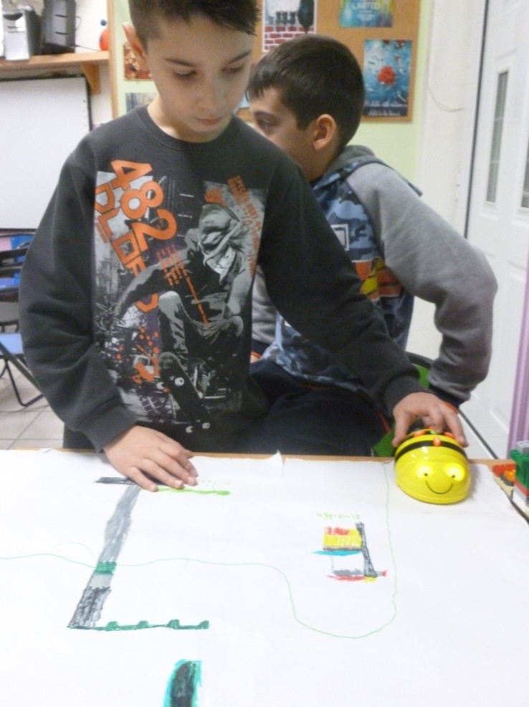The creative play with Lego We do or Bee Bot was very interesting for typical and also for children with behavioral difficulties. Digital character of the play operated like a very powerful magnet for their interests and motivations.

Fig. 1 During their play children had to design maps and direct Bee Bot to follow a specific routes and program Bee Bot to reach goals!

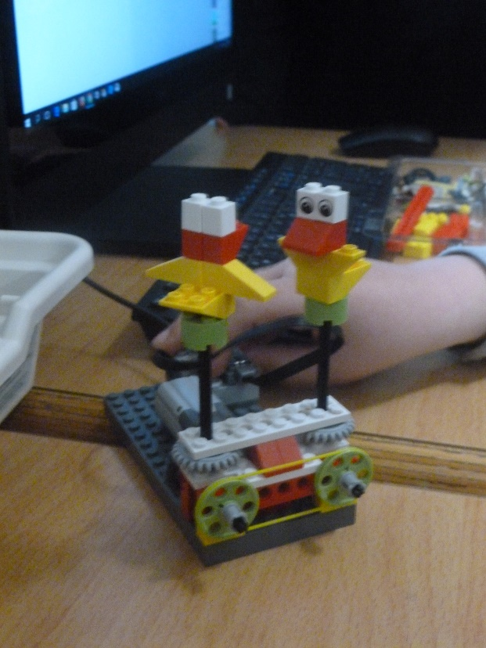

Fig. 2. Children have to cooperate constructing and programming Lego we do in several tasks .In one of the tasks they asked to represent using Lego we do the concept of Cooperation. They constructed two little ducks that make the same movement at the same time and feel happy.

For the two children with behavioral difficulties, it was very difficult to behave according the expectations of their co-workers. Digital play motivated them to cooperate and learn. In this context self –directed and cooperative strategies it was more easy to be taught. Actually, they had to learn and apply a self – directive strategy called «Captain», in order to guide their behavior while they play with we do or bee bot in their team..

Each letter of this word is an advice for children (emerges from the first letter of the corresponding greek word): sit – hear – watch / be careful – obey rules –communicate – win. Children try to work in the team according the orders of “Captain” and the components of a goog-working team. They try to achieve their goals and become captain of themselves. Each of them has the map of captain’s work, which is divided in four parts: 1) plan, 2) individual work, 3) team work, 4) presentation. This is a method of metacognitive thinking on each work. Every child of them draws a small face in these four parts of working to show how he believes that worked through a process of self-evaluation.

The special educator of the team was writing everyday reports and two external observers completed observation sheets in order to write down how the children behave in their team. The conclusions are very important.

This self -directed strategy helped children to concentrate better, to know the next step of the work, to cooperate with others, to communicate politely without disturbing, to be more creative, to evaluate individual and cooperative work, to realize the power and the importance of the team. These skills are very important for their whole life and not only the school reality, so it would be interested to be the subject of a next research.

Additionally, through creative DSI play children found out the basic components of successful team working “The magic recipe of Include”: 1) helping each other, 2) acceptance, 3) power of the team – team spirit, 4) love for the others and for what we are doing, 5) cooperation. As members of this team, the children of the sample managed to respond efficiently and act equally according the strategy they learned, “Captain”, which helped them to encounter problems that could not face alone.

* 1. **Bee bot play for improving creating writing interactions of children with developmental language disorders in inclusive environment.**[9]

Children with developmental language disorders can, with appropriate intervention, improve their communication skills. Such interference strengthens their interaction through an inclusive creative writing program with educational robotics activities. Children construct mechanical structures (building blocks) while solving real problems from the natural world that surrounds them. That makes a parallel learning environment and a play-back environment, safe for testing and searching, suitable for the development of complex cognitive objects is created, where collaborative learning exploits children's interest in new technologies and in particular computers. With these characteristics educational robotics is an example of modern technology. It exudes children with computers, but removing them from the narrow limits of the screen in the tangible, real world. Each training package contains a processor (mind), sensors (sensors), motors and building blocks for construction and creation. "Building Creation" is programmed in a simple programming language - designed for students of different ages and abilities - to make a living action desirable.

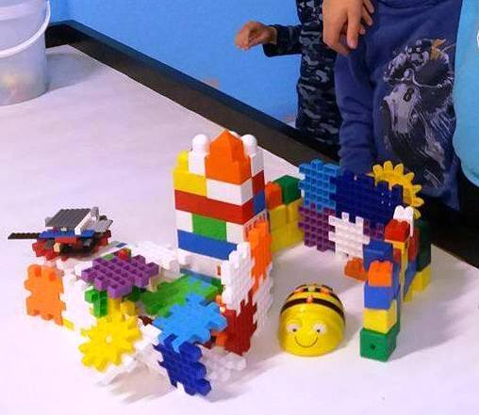

Fig. 3 The aim is not to learn technology, but with the help of technology knowledge and digital power to change attitudes and perceptions of knowledge and learning. In other words, it provides the possibility of achieving discrete goals and positive impacts, such as improving analytical and synthetic thinking, creativity and innovation, critical thinking, problem solving, teamwork, developing communication skills and project management skills .

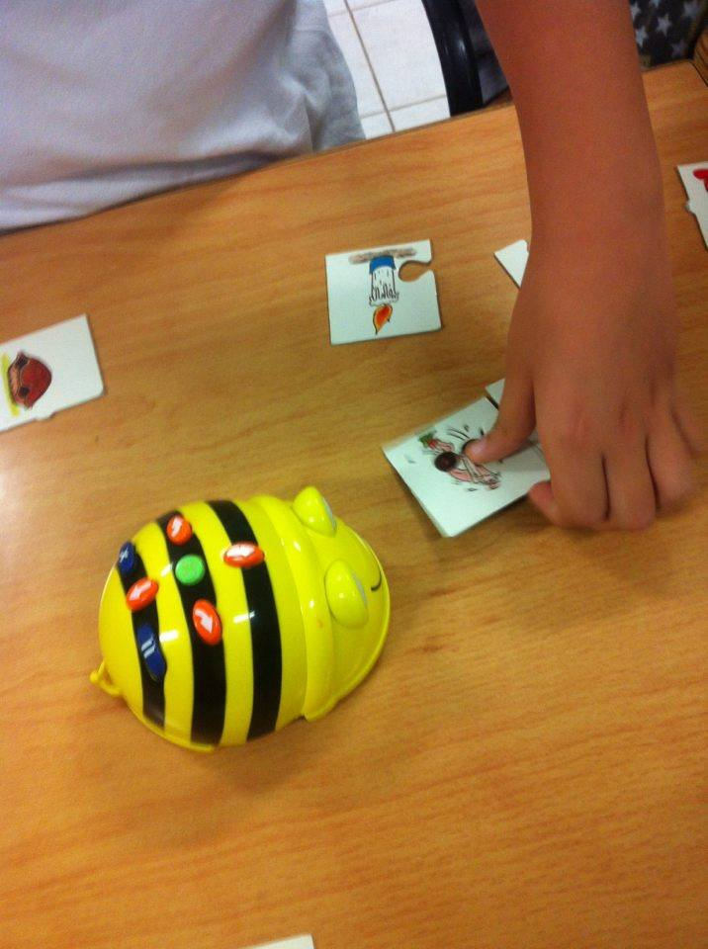

With the help of the technological tools, especially with the beebot (suitable for programming at younger ages), it was attempted to investigate the results of the intervention through an organized case study of a child with speech problems. A structured program of activities was carried out within a group, and the methods of systematic and participatory observation were used. The results of the child's expressive ability, obtained by collecting data from the observation protocols and comparing the evaluations (initial and final), can be described as encouraging.

They are directly linked to the association of two seemingly incompatible scientific fields, but they are subject to a relevant system of operating rules and are one passage towards each other, especially when they concern small age groups or children with cognitive or social-emotional problems. Robotics is a modern way of educational approach and creative writing an ambitious and auspicious system of integrated expression and study of language at all ages. The cooperation of the two can be an educational proposal for teaching, but also for intervention in children who need special educational counseling in the fields of language and communication (Panagiotou, 2018)[10].

* 1. **Video modeling. Why do children with Autism Spectrum Disorders need to be engaged in a learning activity? [11]**

Children engaged in an activity will learn much faster. Video modeling is a tool used to stimulate the visual senses. Children with ASD are visual learners and learn from visual teaching.

“To learn, you need to be paying attention. Anything that detracts your attention is going to have a negative effect on observational learning. If the model is interesting or there is a novel aspect to the situation, you are far more likely to dedicate your full attention to learning.”Bandura, A. (1977). Social Learning Theory. Englewood

Cliffs, NJ: Prentice Hall.

The educational reformer, philosopher and psychologist John Dewey believed that education should be child-centered, active and interactive, and that education must involve the child’s social world and community. (Dewey, J. The child and the curriculum. University of Chicago Press, 1902.)

Where can Video Modeling be used?

VM can be used in therapy, school, home or anywhere there is access to video equipment. Since repetition is vital, using VM in multiple places is a great benefit of using VM in practice as it can be used almost anywhere.

What can Video Modeling teach?

Evidence-based studies have shown that VM can teach communication, academic, play, functional, life and social skills. In addition, VM can work to reverse bad behavior and replace with proper behavior. Watch Me Learn videos based on real life scenarios capitalize on this by teaching multiple skills within one scenario. As in real life, utilizing skills does not happen in isolation.

How to use Video Modeling in practice

Using Video Modeling is simple. Video Modeling simply needs to be watched to be effective. In practice, Video Modeling can and should be used in a more complex way. To maximize learning, Video Modeling is used to teach skills through modeling. Practicing the skill is essential for generalization. This practice should start within a context similar to that of the video. Once this is successful, the natural progression is to practice the skill in different real-world environments, to master generalization.

“The more one has practice, the more likely one is to generalize what one has learned into a style of problem solving or inquiry that serves for any kind of task…or almost any kind of task”

J.S. Bruner 1961

“Ideally”, Jerome Bruner writes, interest in the material to be learned is the best stimulus to learning” (Smith, M.K., ‘Jerome S. Bruner and the process of education’, The encyclopedia of Informal Education, 2002.)

When Can Video Modeling Be Used?

Video Modeling (VM) can be used at almost anytime. Utilizing VM in practice depends on the children or child. Because children love to watch, some teachers and parents use VM as a reward. VM can be used during teaching periods in school. VM can be used as “homework” at home at a convenient time. Children usually write their homework. VM allows them to watch their homework.

* 1. **Improving social interactions of young children with autism in inclusive settings through Bee bot play[12]**

Children with autism face many difficulties when it comes to communicating and having social skills. Properly designed educational methods give those kids the opportunity to develop their social skills and interact with others. Educational robotics is a very attractive way of use the IT in educational programs designed for special kids because they appeal to every child all over the world. The aim of this study is to design and use an interventional program for autistic children, trying to help them evolve their social and communicational skills. After mentioning the main theories connected to autism, a quality research was conducted with a case study of an autistic child. Throughout the research innovative teaching methods were used and new educational tools were developed.



Εικόνα 4 Bee bot supports communication skills of children with autism

The results were very satisfying and the kid participating in the study succeeded in developing her social and communicational skills. A further study on the phenomenon is also suggested as educational robotics can become the key tool in helping children with autism interact with their social surrounding.

* 1. **Yoga in digital environment[13]**

Yoga is a physical and mental practice that has a meditative core. The goal is, through a stable and comfortable body , to finally immobilize the restless mind.(The Yoga Sutras of Patanjali)

1)Goals

The aim of the research is sensory synchronization, the improvement of social relations as well as the proper management and balancing of the fluctuations of the mind ,through yoga sessions . The aforementioned has been proven to be achievable by using digital media that helped the techniques used in sessions.

2)Methodology

In this research, participates Hara, an 11-year-old girl with autism and takes place in a specially designed area, where controlled sensory stimuli are transmitted. Through a sequence of courses, we have thoroughly researched and ending up with specific techniques that have proven to have an effect on the management of sensory fluctuations ,on the improvement of body perception (Journal of Ayurveda and integrative medicine 1 ,2010)as well as on improving the emotional and social ability of the individual. An extremely effective technique is the breathing process (Nadis Sodhana ) as well as the reproduction of sounds at the frequency and intensity required by the child’s condition.

The first and most important condition is the type of lightning, and then the use of frequencies that function as a safety status or reassignment for the child with autism. we have created a fertile ground for the practice, the practitioner follows a sequence of exercises by copying the teacher or by copying projecting images, with great success. The session is completed with deep relaxation, the duration of which, increases impressively overtime.

3) Results

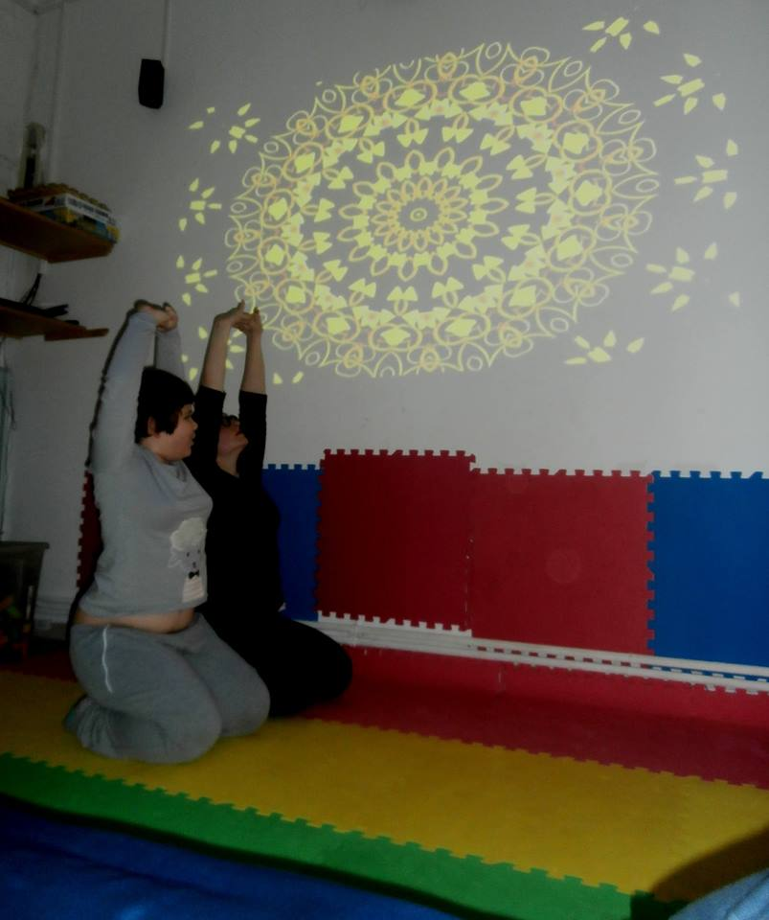The result is to have a child with autism who seeks the systematic practice , because she feels the benefits and facilitations that yoga provides in her everyday life. Hara has improved her mimetic skills, her sensory distinction and her emotional management by remaining calm for a long period. She has also improved her social skills, resulting her participation in activity groups composed by typical-development children. The digital media we use systematically ,is a mandala wall projector, specially adjustable lightning, and, of course ,an adjustable audio player. So, Yoga, under digital conditions, can empower and contribute to the process of improving interactions of people in autistic spectrum disorders.

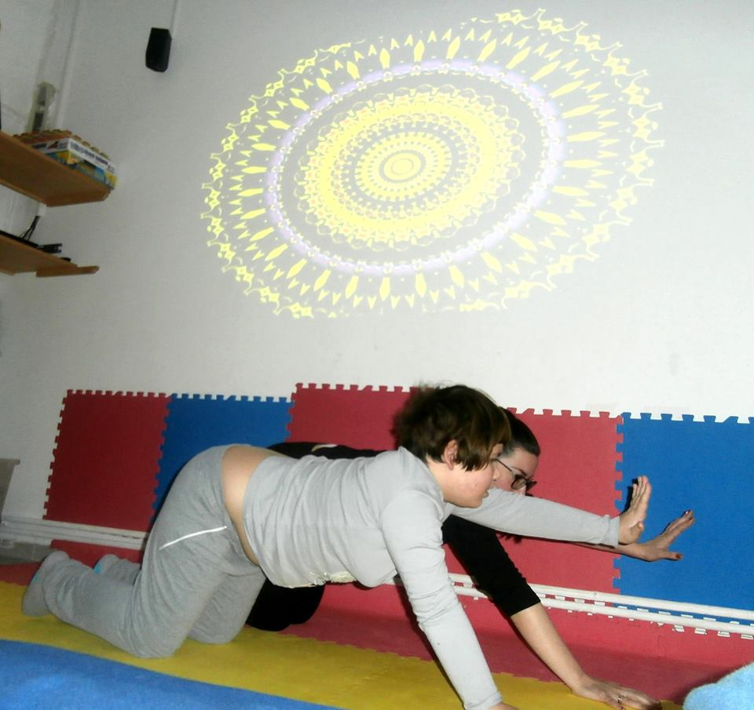

Fg 6 DSI yoga practices mandala wall projector, specially adjustable lightning

Fig. 5 DSI yoga practices mandala wall projector, specially adjustable lightning

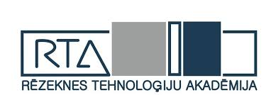

**Digital skills**

Digital skills are a set of knowledge, skills, attitudes, skills and awareness in working with digital technologies: performance of tasks and challenges resolution; communication and cooperation; gathering and organising information; creating and sharing content; effective, responsible, critical, creative, independent knowledge design; ability to understand the role of digital technologies in the construction of reality.

Digital skills describe the competence of a pupil to use digital technologies in the performance of these tasks and ensure the capacity of a pupil in the information society.

Student:

• self-driving uses digital technologies for the reproduction and construction of knowledge, to address tasks and challenges;

• responsibly, critically consumes, shares and shares content created by others;

• manage your digital identity, communicate effectively and collaborate with others;

• use digital technologies for self-implementation, participation;

• critical and constructive assessment of the role of technology and media in society, the development of opinions and knowledge.



<http://www.dcds-project.eu/publications/>

**DigComp as a reference framework for DCDS[14]**

The European Digital Competence Framework for Citizens, also known as DigComp, offers a tool to improve citizens’ digital competence. DigComp was developed by the JRC as a scientific project and with intensive consultation of stakeholders, initially on behalf of DG EAC and, more recently, on behalf of DG EMPL. First published in 2013, DigComp has become a reference for the development and strategic planning of digital competence initiatives both at European and Member State level. In June 2016 JRC published DigComp 2.0, updating the terminology and conceptual model, as well as showcasing examples of its implementation at the European, national and regional level. The current version is labelled DigComp 2.1 and it focuses on expanding the initial three proficiency levels to a more fine-grained eight level description as well as providing examples of use for these eight levels. Its aim is to support stakeholders with the further implementation of DigComp. The DigComp Framework has 5 dimensions:

**Dimension 1:** Competence areas identified to be part of digital competence

o Competence area 1: information and data literacy

o Competence area 2: communication and collaboration

o Competence area 3: digital content creation

o Competence area 4: safety

o Competence area 5: problem solving

**Dimension 2**: Competence descriptors and titles that are pertinent to each area The so called ‘Learning Outcomes’ (21 in total in DigComp 2.1), which will be all taken into consideration for the design of our Digital Competence Development System

**Dimension 3:** Proficiency levels for each competence Eight proficiency levels for each competence have been defined through learning outcomes (using action verbs, following Bloom’s taxonomy) and inspired by the structure and vocabulary of the European Qualification Framework (EQF). Moreover, each level description contains knowledge, skills and attitudes, described in one single descriptor for each level of each competence; this equals to 168 descriptors (8 x 21 learning outcomes). In the DCDS project we will refer to levels 1 and 2 of DigComp 2.1

**Dimension 4:** Knowledge, skills and attitudes applicable to each competence (not included in the last version of DigComp)

**Dimension 5:** Examples of use, on the applicability of the competence to different purposes (reflected, where possible, in the real life scenarios used for the development of the core training material used in DCDS)

One of the main motivators towards enhancing own level of digital competencies it is definitely a direct requirement from the workplace. If an employer is asking the person to take courses and these are covered by the workplace, people will most probably take them.

Secondly, it is important for one to understand the value of the competencies they are gaining (is the competence valued by employers in Latvia or internationally? is the certification acknowledged and trusted?). Official certification is mostly valued amongst public sector employees. Most often people with lower skills have lower motivation to improve their competencies.

Generally speaking, citizens are motivated to improve their digital competences if they don’t have any other choice (eg. CVs’ are only accepted electronically via e-mail), when the alternative costs more (eg. utility payments, if one has to pay offline, he/she is charged extra), or if one sees the economic value (eg. using electronic signature or spend time and money visiting a public institution). Also citizens who have started to improve their digital competences are motivated by safe learning environment, skilful trainers who encourage and support students.

**Critical factors for the implementation of DCDS**

It is important to evaluate the need for DCDS from the public and private sector employer’s perspective. There should be an informative campaign to inform citizens about the value of common evaluation system. Some of the participants pointed out that currently there is a lack of financial resources to adapt a new system. Employment agency data shows that there is a tendency that citizens often choose to take courses with no certification after finishing courses (it was explained as “fear” from exams).

DigComp was mentioned in the context of successful analogies with other fields, as example language learning and evaluation. During the discussions participants agreed that that a common framework would be needed, but they also mentioned that it would be hard to adapt the framework for the wide variety of specific fields and aspects of ICT trainings.



#### Latvian Council of Science Fundamental and Applied Research Project Implementation of Transformative Digital Learning in Doctoral Program of Pedagogical Science in Latvia (DocTDLL), lzp-2018/2-0180

##### Project duration: 01.12.2018 - 31.12.2020 | Funding EUR: 200000

Latvian Council of Science Fundamental and Applied Research Project

##### The goal of the project

The goal is to create new knowledge and technological know-how in the field of transformative digital learning (TDL) in higher education in Latvia based on Canada experience and to ensure transfer of knowledge and skills in the further development of the doctoral study program "Pedagogy", as well as the development of scientific and academic capacity.

##### Main results of the project

* Adaptation of the ,,Personal-Cultural Orientations Scale" and ,,Digital Competency Profiler" to the Latvian conditions and cultural environment.
* Conducting and surveying data processing in the doctoral study program ,,Pedagogy" in Latvia and preparation of a statistical report with the purpose of creating new knowledge in the field of digital learning.
* Development of two 10 credit point or 15 ECTS modules for the doctoral study program ,,Pedagogy" - didactic theories and research of digital learning study courses including practices, synergy of research and practice.

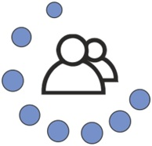

##### **Latvia-Ukraine Cooperation Program Project** **“Gender aspects of digital readiness and development of human capital in region” Project Nr.LV-UA/2018/3**

**Project duration:** 01.01.2019 - 31.12.2020

**Funding:** the total cost of the project is EUR 40,000.00 from the Latvian-Ukrainian Cooperation Program.

**Project partners:** Rezekne Academy of Technologies, Latvia and

Ternopil National Economicuniversity, Ukraine

**Project goal**

Based on the analysis of the digital readiness of university lecturers and students and the cultural and psychological factors of gender inequalities in the technological field, develop / implement a joint on-line teacher / teacher professional development program to reduce the gender disproportion of gender in the regions.

**Project activities**

The project includes seminars and video conferences.

**Project results**

Assessment of digital competence of lecturers and students. Recommendations for improving the training program for lecturers and students.

Promoting gender balance; increasing the digital potential of women for university professionals and students in terms of potential self-realization in digital technology.

Focusing research, education and local government on issues of IT readiness, gender equality, quality and structure of regional human capital during the transition period

Prepared Professional Development Program "Learning for Post-industrial Development" for International Learning in English Online, based on the Community Practice Model, with a view to further implementation of the Ukrainian and Latvian pedagogical activities.

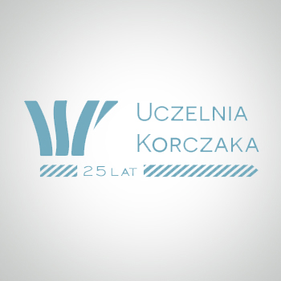

Janusz Korczak Pedagogical University in Warsaw

**Digital Social Innovation: new educational competencies for social inclusion**

**Report from Poland**

dr Stefania Szczurkowska

**1. Principal objectives**

The first step in our work for the project named "Digital Social Innovation: new educational competencies for social inclusion" is to show our experiences regarding topics and practices that are considered essential for digital social innovation/initiatives/activities.

It has been clearly stated that there is no portfolio of digital competencies for social innovation that focuses on the specific needs of social educators and social workers - the definition of the basic portfolio for those social innovation competencies is supposed to be the final goal of this project.

**2. General context of social pedagogy and social work**

Social pedagogy as an academic discipline and a field of practice has evolved in different ways in different countries, as a reflection of cultural norms and attitudes of individuals and societies. However, it has always expressed concern when addressing social inequality, social welfare provision for marginalized groups and facilitating social change by promoting learning, well-being and relationship-oriented connections at the level of individuals and communities.

Regarding principles, social pedagogy is rooted in humanistic values, among which dignity, mutual respect, trust, unconditional appreciation and equality are one of the examples. A basic concept of children, young people and adults as equal human beings means that they have a rich potential and they are considered competent and active agents. Social pedagogy remains an interdisciplinary sub-discipline of pedagogy with a strong interference from the part of such fields of social sciences, as: sociology, psychology, political science, to mention but a few. Social pedagogy is concentrated on theory, methodology and practice of education through the whole of human life and it takes into account on-going changes of external social conditions for which social progress and information technology are of a crucial importance.

The so-called global definition of social work was approved by the International Federation of Social Workers (General Meeting, IFSW) and the International Association of Schools of Social Work (General Assembly, IASSW) in July 2014. Global definition of the social work profession is, as follows:

"Social work is a practice-based profession and an academic discipline that promotes social change and development, social cohesion, and the empowerment and liberation of people. Principles of social justice, human rights, collective responsibility and respect for diversities are central to social work. Underpinned by theories of social work, social sciences, humanities and indigenous knowledge, social work engages people and structures to address life challenges and enhance well-being. The above definition may be amplified at national and/or regional levels." (*Global definition of social work* ..., 2014).

Social work as a practice profession and in solidarity with the disadvantaged people makes efforts to alleviate poverty, liberate the vulnerable and oppressed, and promote social inclusion and social cohesion. Social work intervention is driven by the need to challenge and change the conditions that lead to marginalization, social exclusion and oppression.

**3. National context of social educators and social workers. Legal framework**

The profession of social education in Poland, as research shows, does not exist as a regulated profession nor as a professional category. The understanding of work in a social field means the practice of knowledge of "social pedagogy". When talking about graduates who complete their studies in "social pedagogy", they are attributed the name of "social pedagogues" (*pedagog społeczny*). However, there is no profession as such. A comparative study of the profession of social education in Europe that gives evidence of the Polish case offers the following explanation:

"[...] usually they do not make any differences between workers in the social sphere (*pracownik socjalny*) and social work is understood as a broad concept, like 'working in the social area' or 'working with social actors'. Social pedagogy in Poland is a theory (built as a result of practical action, a set of methodological theories) and an academic discipline. There are three fundamental currents that are taught depending on the academic centers in Poland as the theory of social work practice, as theory of the community work (community work outside institutions) and as a theory of primary care (homes for children, institutions)" (*The profession of social education in Europe*..., 2011).

Social work is not an autonomous academic discipline in Poland, but it is rather a major, and it refers to one of the three leading disciplines: pedagogy, sociology and political science. According to legal regulations of *Social Assistance Act of 12 March 2004 with further amendments of 20 July 2018*, social work is understood as a professional activity whose objective is to help individuals and families to strengthen and regain capability to function in the society through the performance of specific social roles, as well as to create favorable conditions for this aim. Social workers need to fulfill one of the following requirements in order to be engaged in the professional activity:

● hold a college diploma of social service workers;

● hold a diploma of higher education in the field of social work;

● hold a diploma of higher education major leading to the profession of social worker and offered by one of the following fields of study: education, special education, political science, social policy, psychology, sociology, family studies.

There are two levels of specialization in the field of social work: level I whose objective is to acquire complementary knowledge and develop professional skills, and level II whose objective is to improve knowledge and develop skills that are necessary to work with specific groups of assistance/support.

A list of tasks to be performed by social workers, according to the law are, as follows:

"● social work;

● performing an analysis and assessment of phenomena which cause demand for services in the scope of social assistance, as well as qualifying for getting these benefits;

● providing information, hints and help in the scope of solutions of life issues for persons who thanks to this help will solve the problems being the cause of difficult life situation independently; effective use of regulations during accomplishment of tasks;

● assistance in providing counselling for persons who are in difficult life situation, which concerns possibility of solving problems, as well as giving help by proper state and local institutions, and non-governmental institutions, and supporting in gaining this help;

● providing assistance according to the principles of professional ethics;

● stimulation of social activity and inspiration of self-help activities in satisfying essential life needs of persons, families, groups and social environments;

● cooperation with other specialists to counteract and limit abnormalities and negative effects of social phenomena, ease results of poverty;

● initiation of new forms of help given to persons and families who are in difficult life situation, as well as inspiration of appointing institutions that provide services aimed at improving the situation of those persons and families;

● participation in inspiration, working out, implementation and development of the regional and local programs of social assistance pointed at improving the quality of life." (*Social Assistance Act of 12 March* *2004* after: Zdebska, 2016, p. 142, 143).

**4. Social work study programs delivered by Janusz Korczak Pedagogical University in Warsaw and in two branch faculties in the cities of Katowice and Szczecin**

Janusz Korczak Pedagogical University in Warsaw - since 1993 - in one of the oldest non-public higher education institutions in the field of humanities in Poland. Particular attention is drawn at principal specialization areas of European social policy and active social work. Education offers new communication technologies, including e-learning. The experience in e-learning platform is a basic tool for distance education. The Janusz Korczak center has expertise in the education of social workers through level I and level II study programs, postgraduate courses, specialized training courses for social workers, professional training of social workers.

The Warsaw Faculty runs training courses at level I specialization for the profession of social workers. Training is organized in modular program units whose teaching contents list: theoretical knowledge, methodological skills, social skills to be used when working with individuals, families, groups of clients and local communities; professional ethics, legal issues and legislative frameworks, interpersonal communication skills, networks of support for local communities, social projects.

The Katowice Faculty runs training courses at level II specialization for the profession of social workers in the area of social work with individuals and families affected by violence.

The Szczecin Faculty runs training courses at level II specialization for the profession of social workers in the areas of: social work with seniors; social work with individuals and families with mental disorders; social work with the addicted.

In addition to those rather traditional teaching contents for the profession of social work:

● there is a need of competencies enabling changes and improvements of the effectiveness of actions;

● there is a need of competences to use networks of institutions, organizations and specialists in order to solve local community problems successfully;

● there is a need of practical, technical competencies and expertise in modern technological tools in order to facilitate planning and execution of assistance/support measures.

**5. The promotion of social innovation in Poland between 2014 and 2020**

Polish central government and local governments promote social innovation in the light of systemic and local projects under the Knowledge, Education, Development Operational Program for 2014-2020. It must be stressed that the spectrum of the target groups to which project activities are directed is remarkably broad and it embraces: the young generation between 15 and 29 years of age (NEET category: "not in employment, education and training"), including the disabled; micro-, small- and medium-sized enterprises and their employees; social economy entities, social enterprises and their support centers, public administration, judiciary staff, local governments, labour market institutions, employment services, Voluntary Labour Corps, social partners, schools and other educational institutions (staff, students, graduates), universities and research centers, working groups at risk of losing a job, health care providers and their medical staff, people in custody, Gypsies, among others (Klimczuk, 2015).

The presented list of the receivers and beneficiaries of social innovations gives clear evidence how extensive and how multisectoral, and multifaceted the existing demand is.

**6. The concept of digital social innovations (DSI)**

Semantically, DSI is a triple notion as a combination of three words. Their meanings, being interrelated, form the intersection of three spheres: innovation, social and environmental issues, and digital technologies. The research approach adopted by Ozman and Gossart (2017, 2018) shows specific contents of each of them:

"The first sphere is innovation. It refers to the development and diffusion of a (technological, social...) novelty that is not used yet in the market or sector, or country where it is being introduced. The second sphere concerns the solutions put in place to address social and environmental problems, for example through public policies, research projects, new practices, civil society actions, business activities, or by decentralizing the distribution of power and resources through social movements. For example, social inclusion measures facilitate, enable and open up channels for people to participate in social life, regardless of their age, sex, disability, race, ethnicity, origin, religion or socioeconomic status (e. g. the positive discrimination measures that enable minority students to enter universities). Finally, the third sphere relates to digital technologies, which concern hardware and software technologies used to collect, process and diffuse information." (Ozman, Gossart , 2017, 2018, p. 1, 2).

It needs to be stressed that, nowadays, in the European context many technologies no longer have a status of innovations. According to the Eurostat data, no more than 15% of the population of European Union countries do not have access to the Internet. Statistics for Poland reported by the *European Commission Digital Agenda Scoreboard for the Year 2014*, showing percentages of individuals with basic or above basic digital skills, as regards active labour force (employed and unemployed), give evidence of the country position slightly above 50%. In comparison with highly developed European states Poland is placed low in the ranking and it is ahead of no more countries than just only Cyprus, Croatia, Bulgaria and Romania.

Having a look into digital technologies which address real-world problems, DSI can be defined

"[...] as novelties that use, develop, or rely on digital technologies to address social and/or environmental problems. They include a broad group of digital platforms which facilitate peer-to-peer interactions and the mobilization of people in order to solve social and/or environmental problems. Neighbourhood information systems, civic engagement platforms, volunteered geographic information systems, crowdfunding platforms for sustainability or social issues, are some of the cases of the DSI area." (Ozman, Gossart, 2017, 20118, p. 2).

**7. Digital social innovation competencies - the present situation in Poland**

Looking into digital competencies in Poland in general, we have evidence showing that in 2015 no more than 38% of the Polish citizens used the computer in their professional activity; 27% of them have never used the Internet. Meanwhile, also 27% used services of electronic administration and 37% shopped products or services on-line. It means that the country needs development and improvement of digitally competent citizens who will use digital technologies in a confident and safe way for various purposes, such as: working, getting a job, learning, shopping on-line, obtaining health information, being included and participating in society, entertainment, etc. If we look into digital competencies globally, it appears that 40% of Europeans have insufficient or no digital skills and 42% of those people who have no digital skills are unemployed (*DigComp. The digital competence*..., 2019).

**7.1. DigComp reference framework**

For the purpose of the digital society, Poland uses the European Digital Competence Framework for Citizens - known as DigComp and launched in 2015. It offers an efficient tool to improve citizens' digital competence for work and employability, learning, leisure, consumption and participation in society. DigComp is considered to be a crucial and common reference framework functioning as a support of people's life chances and employability. In Poland, activities and initiatives are being undertaken in 5 key areas of 21 competencies set out by DigComp:

● information and data processing,

● communication,

● content creation,

● safety,

● problem solving.

In the context of digital social innovation competencies, a particular emphasis should be given to the second area of communication that includes:

● interacting through digital technologies,

● sharing information and content through digital technologies,

● engaging in citizenship through digital technology,

● collaborating through digital technology.

DigComp can be applicable across various sectors and be a key support for collaboration and development work by educators, trainers, employers, professional bodies and policy-makers. There can be listed diverse uses of DigComp, among which the following receivers are regarded as particularly significant:

● employment services who can assess and certificate job seekers' competencies and provide career guidance and necessary training;

● job seekers' who can certificate their own level of digital competence with the help of the new Europass CV;

● teachers who can improve their professional development;

● learners who can work on their digital competence for the future.

In Poland, training for certification purposes based on DigComp is provided by European Computer Competence Certificate Foundation (ECCC) and by European Computer Driving Licence (ECDL), also known as International Computer Driving Licence (ICDL) in non-European countries. ECDL/ICDL certification is a globally recognized information and communication technology (ICT) and digital literacy qualification. Poland jointed ECDL in 1997, meanwhile since 2017 the country has been member of the ECCC Foundation (main thematic area of expertise - basic digital skills; main thematic area of interest - employability).

**7.2. Good practices of Digital Social Innovation**

European Commission reports in the *2017 European Innovation Scoreboard. EU member* *states' innovation performance* innovations/activities that are under way in Poland in the scope of digital social innovation. It is admitted that social innovation categories embrace the areas of cultural, environmental and technological innovation. Cultural innovation means: relationships, ways of working, social rules and norms. Environmental innovation addresses: homes, buildings, communities, green spaces. Technological innovation refers to digital/information technology, devices. Environmental and social problems, in particular, need solutions with the support of digital technologies. Among good examples, it's worth listing:

● Funtronic Floor, being and interactive projection tool that is simultaneously an interactive floor and table intended both for children of pre-school and school levels, as well as for rehabilitation of adult people and the elderly;

● Smart Board interactive flat panels help educators offer more ways for students to successfully develop skills that are necessary for their unique potential;

● SpolEdu-Cooperative of open education focuses on the creation of high quality open educational resources through a network of educators who value mutual help, cooperation with students and specialists in various fields. Project participants improve their competences in the use of digital tools that help to increase knowledge of copyright, Creative Commons and free licences.

● Migam interpreter eliminates communication barriers of deaf people. It is a service which enables instant video access to a Sign Language interpreter - via a Web browser, mobile application or any device equipped with a camera and the Internet access.

Among other digital social innovation/initiatives/activities, it is worth listing the ongoing actions in Poland - in particular in terms of social and economic investments - that are described and mapped by the European Commission Joint Research Centre report entitled *ICT-enabled social innovation. Evidence & prospective* (2017). Poland gives evidence of a significant share of 40 initiatives, but the country position is lower than of the United Kingdom, Italy, Spain and France. Some good practices are, as follows:

● Express Train to Employment EXPTRAIN (acronym) works as an effective tool facilitating e-social inclusion and it covers thematic areas of: social security, employment and employability;

● Neuroforma - the objective of Neuroforma in Poland is to assist patients who recover from neurological diseases to improve their motor and cognitive functions after hospital treatments, as a part of their rehabilitation process. The receivers of this kind of service can run the Neuroforma program on their home computer with a webcam. Neuroforma is a need-driven initiative undertaken in an open collaboration process and involving a technological company, practitioners, researchers, rehabilitation centers and beneficiaries from various associations.

● Seeing assistants - representing the area of active and healthy ageing - aim to help blind and visually-impaired people in Poland to live more independently. This kind of assistance increases their autonomy and provides them with opportunities and conditions for greater participation and inclusion in society. Technological tools consist of a set of mobile applications which facilitate blind and visually-impaired people's performance of daily activities at home and outside. Those applications react to voice commands, provide location and navigation services, make colour and light source recognition possible. They are also equipped with an electronic magnifying glass and a barcode scanner for automatic recognition of products or objects. An advanced application named "See-Sea" helps navigate through seas, water-ways or reservoirs and it successfully goes beyond daily routine activities, bringing as a result the improvement of the beneficiaries' quality of life.

In general terms, there is an increased demand in Poland of a broadly understood telecare as an integrated care for independent living. Particular attention should be focused on ICT-enabled social innovation advocating active and healthy ageing, and long-term care for older people, as regards prevention, health promotion and rehabilitation. The need to increase the capacity of the elderly to manage self-care and independent living calls for the use of electronic devices, such as sensors and detectors of falls or other anomalous movements of the users together with environmental hazards (gas leaks, fires, temperature changes). The technologies installed in users' homes are connected through a bracelet or a pendant to a telecare system and a telecare service call centre.

For the purpose of social innovation initiatives in support of social services delivery in the area of e-health, it would be desirable to

● train competences of selected individuals living with long-term conditions to help others with similar needs through a dedicated online platform, as well as through the provision of an online emergency support.

**7.3. Digital Social Innovation (DSI) competencies demand**

*Operational Programme Digital Poland for 2014-2020* shows that the level of competencies in the area of the use of public e-services is not sufficient. Priority objectives are focused on strengthening ICT applications for:

● e-government, e-learning, e-social inclusion, e-culture and e-health.

It is stated in the document, as follows:

"The available studies and analysis show that hard (infrastructural or financial) barriers to Internet access are decreasing, while soft barriers, such as the lack of knowledge and informed needs, as well as the lack of appropriate digital competencies, are increasing obstacles to dissemination of new technologies." (*Operational Programme*..., p. 32).

For the purpose of the DSI competencies, it is not enough to acquire computer and Internet skills, but to gain the ability to use the Internet access and online services, in particular public e-services, in practice. It is strongly recommended to use better the potential of Polish students and young researchers who have spectacular achievements and successes in international IT competitions, and transfer this potential into innovative development and wide-spread application of ICT in solving social or economic problems.

Training activities for the development and improvement of digital competencies in the scope of social innovation should be driven to the following directions of teaching how to use e-service in the areas of:

● citizenship,

● health care (prevention, promotion and rehabilitation),

● social benefits,

● taxes and customs,

● business activity,

● justice,

● spatial information,

● digital cultural resources,

●digital scientific resources.

Groups of beneficiaries represent an extensive list of:

● non-governmental organizations (NGO's),

● local government units, their unions ad associations,

● institutions performing activities related to universities of the 3rd age,

● partnerships of non-governmental organizations (NGO's) and local government units.

**Conclusions**

Digital Social Innovation in Poland is a relatively new phenomenon. The demand is growing increasingly in its scope and complexity. Social services are under high pressure due to the risk of unemployment, poverty and social exclusion. The emergence of new challenges, such as ageing population places modernization of social services as one of the chief priorities. Individuals, groups and communities at risk of social exclusion expect proper recognition of their needs, empowerment and assistance offered in the local environment.

Innovation enabled by digital technologies helps to foresee the demand of support, improve quality and efficiency of services, and, finally, provide wider and more personalized services (access to the most disadvantaged). It works thus as a trigger or catalyst of success of social services. At the same time, technologically driven new initiatives/activities reduce the overall administrative burden and facilitate to fill the gaps in the social services provision.

**References:**

*Dig.Comp. The digital competence framework for citizens. Why - what - for whom*, https://ec.europa.eu/jrs/sites/jrch/files/Infographics_DigComp.pdf (accessed 23.02.2019.).

*Digital technologies and social innovation trigger the success of social services, The European Commission's science and knowledge service,* May 17, 2016, https://ec.europa.eu/jrs/en/news/digital-technologies-and-social-in...(accessed 23.02.2019.).

*ECCC Foundation. ALL DIGITAL*, https://all-digital.org/eccc-foundation (accessed 23.02.2019.).

*European Commission Digital Agenda Scoreboard*, 2014, https://eu_science_hub- digcomp-2019-01-25.pdf (accessed 27.02.2019.).

*European Digital Competence Framework for Citizens (DigComp)*, https://ec.europa.eu/social/main.jsp?catId=1315&langId=en (accessed 21.02.2019.).

*2017 European Innovation Scoreboard. EU member states' innovation performance* (accessed 18.02.2019.).

*Global definition of social work*, https://www.ifsw.org/what-is-social-work/global-definition-of-soci... (accessed 06.02.2019.).

Grewiński, M., Karwacki, A., eds., *Innowacyjna polityka społeczna*, Janusz Korczak Pedagogical University in Warsaw, Warsaw 2015.

Klimczuk, A., *Social Innovation Europe: Country Summary: Poland. Social Innovation in* *Poland*, https://www.ssoar.info/ssoar/bitstrean/handle/document/43003/ssoar-2015-klimczuk-Social_Innovation_Europe_C (accessed 23.02.2019.).

Lizut, J., *Emerging innovation in social services*, www.ms.It/derlius/ICCC_2017_ABSTRACTS.pdf (accessed 28.02.2019).

*Operational Programme Digital Poland for 2014-2020*, https://www.polskacyfrowa.gov.pl/media/10410/POPC_eng_1632015.pdf (accessed 27.02.2019).

Misuraca, G., Pasi, G., Urzί Brancati, C., *ICT-enabled social innovation. Evidence & prospective, JRC science for policy reports*, European Commission, Luxembourg 2017, https://ec.europa.eu/jrs/en/publication/eur-scientific-and-technical-research-reports/ict-enabled-social-innovation (accessed 27.02.2019).

Ozman, M., Gossart, C., *What are digital social innovations?*, 2017, updated 2018, http://theconversation.com/what-are-digital-social-innovations-79066 (accessed 02.12.2018).

*The profession of social education in Europe. Comparative survey*, Zaragoza 2011, aieji.net/wp-content/.../The-Profession-of-Social-Education.pdf (accessed 22.02.2019).

*Regulation of the Minister of Labour and Social Policy of 17 April 2012 on specialization as a* *social worker (Text No. 436)*, www.oit.org/dyn/natlex/natlex4.detail?p_lang=en... (accessed 18.02.2019.).

*Social Assistance Act of 12 March 2004 (Text No. 593), with further amendments of 20 July 2018*, www.ilo.org/dyn/natlex/natlex4.detail?p_lang=en&p_isn... (accessed 18.02.2019).

Zdebska, E., *The role and objectives of a social worker in Poland in work with a family with numerous problems, including a family with an untreatable child*, European Scientific Journal, June 2016, https://eujournal.org/index.php/es/article/view/7539 (accessed 23.02.2019).

Date: 11.2.2019

To: Dr. Gilberto Marzano, Ecoistituto del Friuli Venezia Giulia -Udine, Italy - Lead partner

From: Assoc.Prof.Dr & Dr. Honoris Causa Sabahudin Hadžialić, IUT, Travnik

Subject: Report I - Digital social innovation: new competencies for social inclusion

**REPORT - 1**

**Digital social innovation:**

**​new competencies for social inclusion**

**THE LIST OF DIGITAL COMPETENCIES**

**From partner International University Travnik, Travnik, Bosnia and Herzegovina**

First info from my side is that I created a DSI BLOG on our WWW site (on the right upper corner is the link) i within which we can add digital competencies as they arrive on your email from each partner involved or we can put just final creation of summary on it. It is up to you as a leading partner: <https://dsi-2018-2020.weebly.com/> (also, the mentioned BLOG might be open for educators from partner countries to ask questions and get answers from us in regards further development of the project).

Second info is that we created a closed group on <https://www.facebook.com/groups/589042934874480/> which only beneficiaries and educators who are registered can give an answers (we did not want to have some outsiders to creat fake answers) on the mentioned Survey previously to you.

The Survey is still here, but we have done the needed part of geting ansers and analyze of it:

For the educators:

<https://docs.google.com/forms/d/e/1FAIpQLSd8w1c92b6TMAveeyBmt6FP7iqYgPScR6rj_H5mHnpTd5if_A/viewform?fbclid=IwAR2XiZRlocVaurpnGcf9pIH-ACk7Y5cfO-BII4ugaZooQ-wvJBj60g9FesY>

For the beneficiaries:

<https://docs.google.com/forms/d/e/1FAIpQLSdYlijYFHn1-nzWPgV3HziSOfU8Ym3zs4wFr8b_zTyX9IQtsw/viewform?fbclid=IwAR1hrUZP83McTYNAuWQnU06xX28vxiWVTgogu2Ju3y9dJ-W7fNdLudUo3IY>

The list of digital competencies which should be developed within Social media (findings) from IUT side based on the survey we conducted on beneficiaries (11 - kids with special needs - we will involve later up to 24) and educators (11 - skilled educators and volunteers) are the following - for the beneficiaries and educators:

EDUCATORS SURVEY:

a) Developing knowledge (which is insufficient - all of them 100 % answered - lack of knowledge, under the question "Main deficiencies of digital social innovation at the field" are... 3/4 of the answers are related to "insufficient knowledge" and 1/4 of the answers are related the lack of computers within the network) about the way how to communicate on social networks of beneficiaries;

b) „Knowing the way of communication on social networks and how to learn using social networks will help to “: 1. develop a conscience that social networks will re-socialize beneficiaries of our educational services and involvement into the social life of the community (36.4 %) and together with an answer "Development of the conscience that modern technologies do not make a difference between the one who knows and the one who does not know but makes everybody an equal approach" it is 100 %.

b) „I think that there is a need to shape up a special curriculum within digital social innovations “, and on the basis of a) Concrete needs of the beneficiaries/ consumers of the services within the communication with the world that encircles them (45,5 %) and together with "Strategy of the wider community for the re-socialization other beneficiaries/consumers of the services" it is 100 %.

BENEFICIERIES SURVEY:

1. For them, FACEBOOK is are for the game (27,3 %) and area for the exchange of information (77,2 %) and if we link with the one above, to improve the exchange of information, we have to develop more knowledge how to use social media for that.

2. USING OF THE FACEBOOK I GAIN NEW FRIENDS: a) online (9,1 %) and in online and real life as well (90,9 %)

1. I AM LEARNING A LOT USING FACEBOOK: a) „about other people“(9,1 %); and together with „about the way how to communicate with friends“ it makes 81,8 %, while the answer „about the world in which I live got only 9,1 %.

So, the list of digital competencies which we can develop are:

1. Learning more how to use computers for the benefit being on social networks (educators & beneficiaries)
2. Learning how to use social networks for the benefit being more re-socialized (educators & beneficiaries)
3. Enrich the teaching session with the use of new technologies – computers on the network;
4. Learning how to critically (becoming media literate person) use new technologies in personal life as well within the communication process (educators & beneficiaries).
5. Learning how to find, collect and analyze and estimate information from social networks (educators & beneficiaries),
6. Learning how to publish and exchange information on social networks (educators & beneficiaries)
7. Use of information communication technologies + critical thinking.
8. Digital competencies as the part of digital literacy through the enrichment of the one’s knowledge of overall literacy;
9. Learning how to participate in Facebook groups and forums (educators & beneficiaries)
10. Learning how to choose the way of communication on social networks suitable to the certain groups of beneficiaries (educators)
11. Develop a skills of understanding of cultural differences among beneficiaries (social network is worldwide community and worldwide interaction exists) – (educators)
12. Learning how to prevent bulling and manipulation of the beneficiaries by others online (educators & beneficiaries)
13. Learning how to create new content on the social network and to understand security risks (educators & beneficiaries)
14. Learning the way how to creatively express yourself through the social networks (educators & beneficiaries)
15. Learning how to respect intellectual rights on social networks and to become responsible digital citizen (educators & beneficiaries)
16. Learning how to create multimedia content on social networks (educators)
17. Learning how to recognize digital needs and contents (educators & beneficiaries)
18. Learning how to, in innovative way, use new technologies (when on social networks) – (educators & beneficiaries)
19. Learning how to help others to raise their own digital competencies on social networks and in the same time raising own digital competencies (educators & beneficiaries)
20. Learning how to link knowledge of local networks (Facebook) with other part of the Wholly trinity (Twitter & Instagram) – (educators & beneficiaries)

We will have two educators from: <https://centar-duga.com/> from the neighboring town of Novi Travnik (20 km from Travnik)

1. Ms. Aida Jusić, MA - pedagogue-educator-psychologist

1. . Ms. Edita Berberović, defectologist - logopead (speech therapist)

Later on, we will have one parent (until they agree which one knows English as well)

*Team involved in the creation from the International University Travnik:*

Created (survey and this report, including WWW site) by Assoc. Prof. Dr & Dr. Honoris Causa Sabahudin Hadžialić

Initial contact with DUGA EDUCATIONAL-REHABILITONAL CENTER form NOVI TRAVNIK and coordination with them: Zlatko Mecan, MA

Online putting of the Survey and methodology output – graphic in Bosnian/Croatian/Serbian language (Excell and Ptt) – Merima Delić, MA

Creation on the Facebook and moderating the group while conducting the survey – Almedina Hatarić, Ma

Team held so far 3 (three) meetings to develop all needed steps in starting of our part of the Project.



**Faculty of Health Studies, Croatia**

**Digital competences/topics to be considered for the portfolio:**

1. The level of digital education is quite different in various countries and professional/social/age groups: it is necessary to **evaluate the average digital competence of the target population** which is to be addressed by social educators (e. g., patients, children, . The method to be used is questionnaire (or, in individual approaches, interviews) detecting: a) the level of formal/informal education related to digital media; b) openness to digital media and readyness to use them; and c) access to digital media (Internet, i-phones, smartphones, tablets, etc.).
2. If we consider the application of digital media in healthcare (correctly perceiving patients as one of the vulnerable groups), it is necessary to **evaluate the average digital competence of healthcare workers** as well (physicians, nurses, etc.). Here, too,

the method of evaluation might be an appropriate questionnaire providing data on both the knowledge and motivation of healthcare workers in one particular country/institution related to mastering and/or learning how to master digital technology.

1. Social educators themselves should be educated not only in those digital media that are currently used: they should know about **the existance/non-existance of older versions of the same software**. Namely, it is possible that intellectually or physically disabled persons will not be capable of using the most recent programmes or programme versions: in that case, social educatiors may find the solution in applying software versions which are not up-to-date, but still help the beneficiary reach the educator's goal. In order to acquire such a competence, the education of social workers has to be adequatly broadened.
2. Due to the particularly rapid pace of development of new digital technologies, it is necessary that social workers **attend courses on a yearly basis**, following the trends and improving their knowledge and skills in applying digital technology. Those courses might be organised regularly by a university or other accredited organisation, maybe even at the regional/international level, and combined with the exchange of good practices. The course organisers may be endorsed by issueing international licences helping standardise and eventually monitor the quality of digital social innovation.
3. Social workers using digital technology certainly will come in touch with personal data of the beneficiaries. Thus, social workers will have to be informed about the fundamental elements of the EU directive called General Data Protection Regulation (GDPR), and treat the data they gather in accordance with the directive.

1. Nanou A., Patsidou M. (2017) Issues on Special Education . Quarterly magazine for education Issue 76, August - September
2. Ballard 2018 [Inclusion, Paradigms, Power and Participation](https://www.taylorfrancis.com/books/9780429469084/chapters/10.4324/9780429469084-1) in (Catherine Clark, Alan Dyson, Alan Millward eds) Towards Inclusive Schools?
3. <http://udltheorypractice.cast.org/login>
4. http://udltheorypractice.cast.org/reading?6&loc=intro.xml_l1069
5. DIGITAL SOCIAL INNOVATION: A PRELIMINARY PORTFOLIO OF COMPETENCIES FOR SCHOOL SOCIAL WORKERS

   Gilberto Marzano,1,2 Joanna Lizut,2 Luis Ochoa3
6. # [Gilberto Marzano](https://www.amazon.com/s/ref=dp_byline_sr_ebooks_1?ie=UTF8&text=Gilberto+Marzano&search-alias=digital-text&field-author=Gilberto+Marzano&sort=relevancerank) (Author), [Miroslaw Grewiński](https://www.amazon.com/s/ref=dp_byline_sr_ebooks_2?ie=UTF8&text=Miroslaw+Grewi%C5%84ski&search-alias=digital-text&field-author=Miroslaw+Grewi%C5%84ski&sort=relevancerank) (Editor) Introduction to Social Innovation

  
7. (Sakalidou, Stathopoulou, Gavriilidou, Nanou 2015, Patsidou, Nanou, Rapatopoulou, 2015 Raptopoulou, Tsiomi, Nerantzis, Nanou, 2017 Tzaferis, Tsiomi, Vassiliou, Nanos 2015, Panagiotou 2018, Kotou, 2017, Nanou& Patsidou 2017).
8. Nanou A. & Giatrakou A. (in progress) Self – directive strategies for children with Behavioral difficulties/
9. Panagiotou G. 2018, improving creating writing interactions of children with developmental language disorders in inclusive environment MA dissertation University of west Macedonia
10. . Panagiotou G. 2018, improving creating writing interactions of children with developmental language disorders in inclusive environment MA dissertation University of west Macedonia
11. Sakalidou Eriffily (in progress)
12. Kotou Despoina 2017. Design and implementation of a innovative educational program through structural approach with the objective of the development of social and communication skills of children in the autistic spectrum. MA Dissertation EUC.
13. Nanou & Kontogianni (in progress) Yoga in Inclusion possess
14. 1 The information provided under this section have been extracted from: Carretero, S.; Vuorikari, R. and Punie, Y. (2017). DigComp 2.1: The Digital Competence Framework for Citizens with eight proficiency levels and examples of use, EUR 28558 EN, doi:10.2760/38842

    https://ec.europa.eu/jrc/en/publication/eur-scientific-and-technical-research-reports/digcomp-21-digitalcompetence-framework-citizens-eight-proficiency-levels-and-examples-use