

Digital Social Innovation

**Ecoistituto del Friuli Venezia Giulia**

Via Ferraris, 1 – 33100, Udine

**Digital social innovation: new educational competences for social inclusion (DSI)**

**Project N. 2018-1-IT02-KA204-048479**

**Final report**

**Premise**

The DSI project will end on 11.11.2020.

This project is expected to produce the following results:

- to define the competencies essential to implement ICT-based social inclusion initiatives/services (social inclusion);

- to motivate/engage social educators and social volunteers into social innovation ideas/initiatives (social cooperation);

- to support social educators and social volunteers in acquiring and developing basic skills and key competencies in digital social innovation, to foster their socio-educational and personal development, as well as to improve their employability (social innovation).

Accordingly, partners ought to show how these results have been reached.

**Competence essential to implement ICT-based social inclusion initiatives/services**

The main competences resulted from the comparative analysis carried out by partners are:

1. ***Learning how to use social networks for the benefit being more re-socialized (educators & beneficiaries) –*** The correct way of using social networks is a basic competence.
2. ***Enhancing the knowledge of the use of digital technologies.*** The knowledge of digital technology is a crucial factor of digital innovations.
3. ***Critical thinking.*** Developing DSI needs critical thinking abilities. Critical thinking is that mode of thinking — about any subject, content, or problem — in which the thinker improves the quality of their thinking by skillfully analyzing, assessing, and reconstructing it.
4. ***Learning how to find, collect and analyze and estimate information from social networks***. It is crucial to leverage the opportunities offered by the internet but one needs to determine the authorities of sources.
5. ***Digital media literacy.*** Digital media literacy is essential to use digital contents.
6. ***Interacting through a variety of digital technologies.*** People must understand what kind of technology is appropriate for a given context.
7. ***Collaborating through digital technologies.*** Digital tools should support collaborative activities and the creation of knowledge through the combined efforts of users***.***
8. ***Netiquette***. Users should be aware of behavioral norms and know-how while using digital technologies and interacting with others.
9. ***Managing digital identity***. Users’ should know how to manage and protect their digital identity (*DigComp. Digital Competence Framework for* *Citizens*, 2019).

**Motivation/engagement of social educators and social volunteers**

The development of digital competence shows its presence "[...] through school curricula, teacher-specific digital competencies, the assessment of students' digital competencies and the use of technology in assessment and testing, and finally, the strategic approaches to digital education across Europe with specific reference to policies supporting schools" (*Digital Education at School in Europe*, 2019, p. 9).

The development of digital competence is included in most European Union countries at all education levels. However, in contrast with traditional school subjects, it is not only considered as a topic in its own right, but also as a transversal key competence. The education system in Poland combines two approaches: digital competence is either addressed as a compulsory separate subject or integrated into other compulsory subjects. Learning outcomes relate to all five digital competence areas set out by the European Digital Competence Framework for Citizens - known as DigComp and launched in 2015:

● information and data literacy,

● communication and collaboration,

● digital content creation,

● safety,

● and problem solving.

As regards the area of information and data literacy, schools focus on the competence of evaluating data, information and digital content.

For the area of communication and collaboration, particular attention is given to collaborating through digital technologies and to managing digital identity.

As regards digital content creation area, the emphasis is given to developing digital content and programming/coding.

For safety area, particular significance is addressed to protecting personal data and privacy, as well as protecting health and well-being.

As regards problem solving area, identifying digital competence gaps is stressed, in particular.

**A portfolio of digital competencies for school social workers**

As an example, partners developed a portfolio of digital competencies for school social workers. It concerns three main basic scopes:

* Digital technology understanding - this encompasses knowledge about the multifarious dimensions of the digital revolution and the impact on school activities.
* Digital-based educational processes - these comprise both theoretical and practical knowledge of online educational models as well as teaching-learning practices that can support the implementation and running of e-learning and distance learning programs.
* Some sectorial knowledge - this includes knowledge in specific fields such as social learning, social telerehabilitation, and social networking tools.

A basic competence for school social workers concerns the use of social media and online technologies. Online tools can be useful for communicating and interacting with student families and teaching staff at distance. However, using digital tools to support and counsel the school community is not sufficient to master digital applications. New concepts and competencies are needed, for example, school social workers should be taught to use social media, and should know what the positive and negative social impacts of digital technology are. In this way, they can, for instance, lead students to experiment peer-learning initiatives aimed at helping their classmates in the use of digital devices and applications as well as at reducing the risk of cyberbullying. Indeed, a low level of skills in using digital technologies has been associated with an increased likelihood of being cyber-victimized (Slonje & Smith, 2008). In this regard, it has been underlined that one can interpret the holding of power in online relationships as a more advanced technical skill as well as having the ability to modify pictures, or that being able to perform other manipulations of data and user profiles can offer inviting opportunities to those who are more expert to cyberbully the less digitally skilled (Dooley, Pyżalski, & Cross, 2009).

According to the analysis of the anti-cyberbullying programs in place, the suggestions from experts, and our own in-field experience (Marzano & Lizut, 2019b), the basic competencies and skills of a school social worker involved in cyberbullying prevention initiatives should include:

* Basic theoretical knowledge and practical skills in pedagogy and social pedagogy, orientated to the design, implement, and manage cyberbullying prevention programs.
* Theoretical and practical skills to design, implement, manage, and evaluate educational projects in schools in order to respond to the growing demand for cyber safety.
* Thorough knowledge of learning models and their underlying psychological theories, in particular, of those models based on collaboration and leadership.
* Thorough knowledge of social networking applications, messenger applications, and interactive tools.
* Thorough knowledge of cyberbullying policies and legal aspects.
* Competence to deal with the impact and identification of cyberbullying.
* Capability to define and submit questionnaires as well as data analysis competence.
* Skills and capabilities to design, implement, manage, and evaluate interventions and processes of continuous training, also through multimedia technologies, distance learning, collaborative online learning, digital social learning, etc.
* Skills to use parental control applications, content filters, and other anti-cyberbullying tools.

**Digital competences for anti-cyberbullying intervention**

Table 1 synthesizes the basic scopes and competencies required by a school social worker in order to perform anti-cyberbullying interventions.

School social workers should also possess competencies to contrast the abusive use of the internet. According to Griffiths (2000), individuals who use the internet excessively are not addicted to the internet per se but, rather, use it as a medium to fuel other addictions. A gambling addict who chooses to engage in online gambling is merely using the internet as a place in which they can enact their (addictive) behavior (Widyanto & Griffiths, 2006). This said, the excessive use of the internet can lead to degenerated behaviors and produce serious consequences. Online gambling, for example, does currently represent a very real and established risk. Over the last decade, the increasing evidence that minors are engaging in gambling and developing, as a consequence, more gambling-related problems has been highlighted by numerous authors (Griffiths, 2009; Livingstone & Haddon, 2008; Monaghan, Derevensky, & Sklar, 2008). Nowadays, we can observe the ever-increasing growth of casino games on social media platforms (Gainsbury, Hing, Delfabbro, & King, 2014).

Over the last few years, alarm bells are increasingly being sounded that digital media are providing greater opportunities for the social transmission of behavioral addictions as a consequence of adolescent exposure to favorable presentations of addictive substances such as alcohol, tobacco, and marijuana, as well as behaviors such as gambling on social and other online media (Romer & Moreno, 2017).

***Table 1. Anti-cyberbullying basic scopes and competencies of a school social worker***

|  |  |
| --- | --- |
| Basic scopes | Basic competencies and skills |
| Cyberbullying and cyber threats understanding | * Carrying out systematic review of the phenomenon at school and data analysis; * Deep knowledge of the different forms of cyberbullying * Expertise on social networking sites * Awareness of the roles of bystanders and parents * Familiarity with quality assessment processes * Knowledge of the school world and dynamics * Leadership and team work * Change management |
| Educational processes | * Educational models (in general) * Educational practices used in anti-cyberbullying programs * Peer learning model * Community learning * Collaborative learning * Digital social learning * Parent-training |
| Sectorial knowledge | * Legal implications * School anti-cyberbullying statutes * Use of parental control software * Use of filters and blocks * Use of online collaborative tools * Creation and use of wikis, blogs, forums, and apps * Use of messenger apps * How the internet works * Anti-cyberbullying coping strategies * Digital dependencies |

To increase the competencies of school social workers, new curricula should be developed and new disciplinary scopes should be defined in various fields such as:

* Psychology of interactive processes on the internet
* Social media anthropology
* Online educational methodologies
* Use of information and communication technologies
* Computing techniques for school social workers

This is no easy task since many elements present in the current curricula for social educators will have to be rethought and integrated with new notions and knowledge regarding digital technology and other matters. Nevertheless, if contemporary problems such as cyberbullying are to be tackled, it is necessary to break the boundaries of disciplinary domains. For example, according to Spears and Kofoed, one should consider that childhood is a social construction and that children should be looked upon as social actors, not only as outcomes of social processes (Spears & Kofoed, 2013).

From this perspective, adopting a social anthropological approach could be useful. We contend that it is essential to create collaborative processes among the specialists of the scientific domains involved in education science in order to provide social educators with the knowledge, competencies, and skills necessary to face the contemporary social challenges.

**Social innovation**

Ecoistituto, in collaboration with the associated partner “Centro Micesio”, Udine, developed a training course on DSI for social educators and social volunteers. This course has been approved and cofounded by the Friuli Venezia Giulia Region and will take place on 2021.

Figure 2 shows the announcement of the training course on DSI.

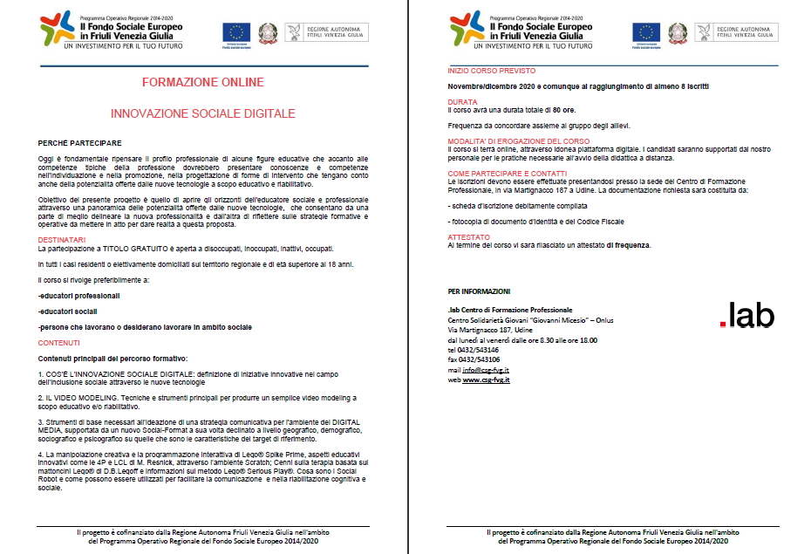

Figure 2. The training course on DSI cofounded by the Friuli Venezia Giulia region

From research and discussions carried out by partners, it emerged that professionals who possess extensive skills and knowledge as school social workers are expected to have digital competences in the following scopes:

● Digital technology understanding - this encompasses knowledge about the multifarious dimensions of the digital revolution and the impact on school activities.

● Digital-based educational processes - these comprises both theoretical and practical knowledge of online educational models, as well as teaching-learning practices that can support the implementation and running of e-learning and distance learning programs.

● Some sectorial knowledge - this includes knowledge in specific fields, such as social learning, social telerehabilitation, and social networking tools" (Marzano, Lizut, Ochoa, 2019, p. 324).

To master social media and to be thoroughly proficient in the use of mobile phones, and the Internet, in general, constitute indispensable conditions for effective performance of the school social workers in their everyday work.